

**Arab Academy for Science, Technology, & Maritime Transport**

## College of Computing and Information Technology, Cairo

B. Sc. Final Year Project

## Askun

##### Live better

Presented By:

*Mohamed Yasser Hosni Abdelrahman Soliman Ahmed Ali Ibrahim Mohamed Waleed*

Ziad Amr Supervised By:

Dr. Ahmed Dahroug Dr. Menna Maged

J a n u a r y – 2 0 2 4

# DECLARATION

I hereby certify that this material, which I now submit for assessment on the program of study leading to the award of Bachelor of Science in Computing and information technology is entirely my own work, that I have exercised reasonable care to ensure that the work is original, and does not to the best of my knowledge breach any law of copyright, and has not been taken from the work of others save and to the extent that such work has been cited and acknowledged within the text of my work.

**Student Name:** Mohamed Yasser

**Registration No.:** 20104347

**Signed: Date:** 10/ 1/ 2024.

**Student Name:** Ahmed Ali

**Registration No.:** 20104656

**Signed: Date:** 10/ 1/ 2024.

**Student Name:** Abdelrahman Soliman

**Registration No.:** 20104453

**Signed: Date:** 10/ 1/ 2024.

**Student Name:** Mohamed Waleed

**Registration No.:** 20105592

**Signed: Date:** 10/ 1/ 2024.

**Student Name:** Ziad Amr

**Registration No.:** 20106000

**Signed: Date:** 10/ 1/ 2024.

# ACKNOWLEDGEMENT

"We would like to express our deep gratitude to the Arab Academy for Science and Technology for their support and guidance throughout this project. Their invaluable contribution has been a key factor in the success of our work.

We are also extremely grateful to our supervisors, Dr. Ahmed Dahroug and Dr. Menna Maged, for their valuable insights and guidance. Their expertise and support have been invaluable to us, and we are deeply thankful for their ongoing support and encouragement.

Finally, we would like to express our gratitude to our country and government for providing the resources and support necessary to complete this project. We are proud to be able to contribute to the development and advancement of our nation through our work."

Table of Contents

C h a p t e r O n e 6

INTRODUCTION 6

* 1. INTRODUCTION 6
  2. SCOPE 6
  3. PROJECT STATEMENT 8
  4. PROJECT OBJECTIVES 8
  5. CHALLENGES 9
  6. Constraints 9
  7. Risks 14

Risk 14

Risk Mitigation Strategies 14

* 1. Assumptions and limitations 15
  2. Project Planning 16
  3. Document Structure 21

C h a p t e r T w o 22

MARKET ANALYSIS & RELATED WORK 22

* 1. INTRODUCTION 22
  2. 4Ps 22
  3. SWOT Analysis 26
  4. PESTEL analysis 29
  5. Related Projects 34
  6. RELATED Work 38

. 38

* 1. Research Gap 39

C h a p t e r T h r e e 41

METHODOLOGY & PROPOSED WORK 41

* 1. INTRODUCTION 41
  2. METHODOLOGY 41
     1. **DATA GATHERING** 42

INTENDED USERS 42

* + 1. **DATA GATHERING** 43

INTENDED USERS 48

* 1. PROPOSED MODEL 49
  2. SYSTEM REQUIREMENTS 50
     1. **Functional Requirements** 50
     2. **Non-Functional Requirements** 54
     3. **External interface Requirements** 56
     4. **System features** 57
  3. SYSTEM ANALYSIS 58
     1. **Database Design/ ERD** 58
     2. **System Class Diagram** 59
        + **Use Cases** 60

**Detailed Use Case** 65

**3.5.5 Sequence Diagram** 89

* 1. System Interface 90

C h a p t e r Five 91

CONCLUSION & FUTURE WORK 91

* 1. FUTURE WORK 91
  2. CONCLUSION 91

References 92

# LIST OF FIGURES

Figure 1 WBS 18

Figure 2 Block Diagram 49

Figure 3 ERD 58

Figure 4 Class Diagram 59

Figure 5 USE CASE 60

Figure 6 Chatbot 61

Figure 7 Bank Use Case 61

Figure 8 API Use Case 62

Figure 9 Admin 62

Figure 10 Real estate Agent 63

Figure 11 User (Guest, Registered) 64

Figure 12 Sign Up with OAuth 2.0 65

Figure 13 Login with OAuth 2.0 67

Figure 14 Buy Property 69

Figure 15 Sell Property 71

Figure 16 Rent Property 73

Figure 17 Make Investments 75

Figure 18 Manage Property Listings 77

Figure 19 List Property 79

Figure 20 Process Payment for Property Purchase 81

Figure 21 Integrate with External Services 83

Figure 22 Provide Automated Assistance 85

Figure 23 Enforce Contractual Agreements 87

Figure 24 Sequence Diagram 89

Figure 25 APP Interface 90

Figure 26 Web Interface 90

# ABSTRACT

The real estate industry is undergoing a transformative shift driven by the integration of innovative technologies that streamline processes, enhance user experiences, and foster a transparent and secure environment. This paper delves into the groundbreaking features of Askun, a revolutionary web and mobile application that harnesses the power of smart real estate, blockchain technology, AI chatbots, 360-degree virtual tours, and immersive image viewing to redefine the way buyers and sellers interact with properties.

Askun's smart real estate capabilities empower users with data-driven insights that guide informed decision-making. By analyzing vast amounts of real estate data, the platform generates personalized recommendations, market trends, and predictive analytics tailored to each user's unique needs and preferences. This data-driven approach ensures that users are equipped with the knowledge they need to make sound investments in the real estate market.

The application integrates machine learning algorithms to analyze market data, individual preferences, and current property listings to generate personalized recommendations for users. This data-driven approach ensures that users are presented with the most relevant and suitable property options, eliminating the need to sift through vast amounts of irrelevant information.

Furthermore, Askun leverages blockchain technology through Metamask to facilitate secure smart contracts and cryptocurrency transactions, ensuring transparency and security in property dealings. The integration of AI-powered chatbots by Gemini Google AI enhances user interaction and support, providing instant assistance and personalized responses.

Additionally, Askun incorporates advanced visualization features such as 360-degree virtual tours and immersive image viewing, allowing users to explore properties in detail from the comfort of their own homes. The platform also utilizes Google Maps for precise location services and property mapping, further enhancing the user experience.

In summary, Askun is at the forefront of the real estate industry's digital transformation, offering a comprehensive and user-centric platform that leverages cutting-edge technologies to streamline property transactions and empower users with data-driven insights.

C h a p t e r O n e

# INTRODUCTION

* 1. INTRODUCTION

The real estate industry has witnessed a paradigm shift with the advent of technology, and this Software Requirements Specification (SRS) document outlines the fundamental requirements for the development of a cutting-edge real estate website. The platform aims to revolutionize the process of buying, renting, and selling properties by leveraging advanced technologies, including blockchain, AI chatbots, 360-degree virtual tours, and Smart Real Estate (SRE).

This document provides a comprehensive overview of the purpose, intended audience, use, scope, definitions, challenges, risks, and risk mitigation strategies associated with the development of the Askun platform.

#### SCOPE

The project scope includes the following processes:

* + 1. Login/Sign Up with OAuth 2.0:
       - Enable Guest Users to sign up using OAuth providers (Facebook, Google, Apple).
       - Integration of the platform with external API services and the database for user authentication.
    2. Buy, Sell, Rent, Invest in Property:
       - Enable Registered Users to initiate financial transactions for property transactions.
       - Execution of smart contracts to facilitate secure transactions.
    3. Manage Property Listings:
       - Allow administrators to access and manage property listings.
       - Approval or removal of property listings by administrators.
    4. List Property:
       - Enable Real Estate Agents to list properties through a user-friendly interface.
       - Submission of property details to the Property Listing Database.
    5. Process Payment for Property Purchase:
       - Initiation of the purchase process by users.
       - Calculation of total purchase amount, selection of payment method, and payment processing through the bank via a Payment Gateway.
    6. Provide Automated Assistance:
       - Implementation of a chat bot system for user-initiated interactions.

##### Goals

The goals of the ASKUN Real Estate Platform are as follows:

* To establish a reliable and secure authentication process using OAuth 2.0.
* To enable users to buy, sell, rent, and properties with the support of financial transactions and smart contracts.
* To empower real estate agents to easily list properties on the platform.
* To ensure a smooth and secure payment process for property purchases.
* To implement an advanced chatbot system for automated assistance.

##### Benefits

The ASKUN Real Estate Platform offers several benefits:

* Increased convenience for users through OAuth 2.0 integration for seamless sign-up and login.
* Enhanced security and transparency in property transactions through smart contract execution.
* Empowerment of real estate agents with a user-friendly interface for listing properties.
* Secure and streamlined payment processes for property purchases.
* Enhanced user engagement and satisfaction through an advanced chat bot system.

#### PROJECT STATEMENT

The ASKUN Real Estate Platform project endeavors to create an innovative and comprehensive ecosystem that transforms the real estate industry. This platform will cater to the diverse needs of Guest Users, Registered Users, Real Estate Agents, and Administrators. By leveraging advanced technologies, including OAuth 2.0 for authentication,360 virtual Tour, smart contracts for secure transactions, and a sophisticated chat bot system, ASKUN aims to redefine user experiences and industry standards.

The primary goals of the project include implementing seamless authentication processes, facilitating secure property transactions, streamlining property listing management, empowering Real Estate Agents with user-friendly interfaces, ensuring secure payment processes, and providing automated assistance through a cutting-edge chat bot system.

The ASKUN Real Estate Platform aspires to bring the following benefits to its users: an enhanced user experience through a secure sign-up and login process, transparency and security in property transactions facilitated by smart contracts, efficient property listing management for administrators, a simplified listing process for Real Estate Agents, secure and streamlined payment processes, and an advanced chat bot system for instant and accurate user assistance.

The project timeline is structured to ensure timely deployment, and stakeholders involved include Users (Guest, Registered, Real Estate Agents), Administrators, External **API** Service Providers, Financial Institutions, and the Development Team. This project statement is subject to approval by all stakeholders, marking the beginning of a transformative journey for the ASKUN Real Estate Platform.

In Summary the ASKUN Real Estate Platform project seeks to reshape the real estate landscape by integrating cutting-edge technologies to enhance user experiences and streamline industry processes. With a focus on secure transactions, efficient property management, and user empowerment, ASKUN aims to create a user-friendly platform that sets new standards for the real estate sector.

#### PROJECT OBJECTIVES

* **User-Friendly Website:** Develop a website that is easy to navigate and intuitive, catering to users with varying levels of technical expertise.
* **Blockchain Integration:** Implement blockchain technology seamlessly to ensure secure and transparent financial transactions.
* **Chatbots for Real-Time Assistance:** Integrate chatbots to provide real-time assistance, enhancing customer support and engagement.
* **3D Scanning for Immersive Exploration**: Implement 3D scanning or 360-degree views to offer an immersive exploration of properties, providing more interactive and engaging experience.
* Secure **Authentication and User Management:** Implement secure authentication methods using Firebase to protect user data and manage user accounts effectively.
* **Social Media Integration:** Enable users to connect and share their experiences via Facebook, Google, and Apple APIs, enhancing social engagement and marketing reach.
* **Cross-Platform Consistency:** Ensure a consistent user experience across both web and mobile platforms using React and React Native.
* **Property Management Tools:** Provide tools for property owners to manage listings, track inquiries.
* **Secure Payment Processing:** Ensure secure and efficient payment processing methods, addressing concerns over credit card security and large transaction amounts.

#### CHALLENGES

* **Integrating Complex Blockchain Technology:** The challenge lies in seamlessly integrating advanced blockchain technology to ensure secure and transparent financial transactions.
* **Developing an Intuitive User Interface:** Designing a user interface that caters to diverse user groups and ensures a smooth and intuitive navigation experience.
* **Ensuring Compatibility with Various Devices and Browsers:** The platform should be compatible with a wide range of devices and browsers to ensure accessibility for a broad user base.
* **Protecting User Data and Maintaining Privacy:** Robust measures must be implemented to protect user data and maintain privacy, addressing concerns related to data security and confidentiality.
* **Addressing Potential Security Vulnerabilities:** The platform must proactively identify and address potential security vulnerabilities to ensure a secure environment for users.

##### Constraints Technical constraints

* **Hardware and Software Compatibility:** Implications for the real estate system: The system must be compatible with a range of devices and browsers to ensure accessibility for users with diverse technology preferences.
* **Integration with Existing Systems:** Implications for the Real Estate System: Integration with external systems, such as property databases or financial software, may be limited by current technologies and data formats.
* **Security Standards:** Implications for the Real Estate System: Adherence to security standards and protocols is crucial given the sensitive nature of real estate data. Secure data transmission and storage practices are non-negotiable.
* **Integration with External Systems:** Smart real estate systems may need to integrate with external systems, such as accounting software, customer relationship management (CRM) platforms, and building management systems, requiring data exchange protocols and compatibility standards.
* **High Development Costs:** Implementing blockchain and smart contracts can be expensive due to the need for specialized developers and additional security measures.

##### Realistic Constraints:

* **Real Estate Industry Standards:** The development and implementation of smart real estate systems should align with industry standards and data formats to ensure interoperability and compatibility across different platforms.
* **Data Governance and Privacy Regulations:** Smart real estate systems must adhere to data governance frameworks and privacy regulations to protect sensitive data and ensure responsible data handling practices.
* **Budget Limitations:** Real Estate System Financial constraints may influence decisions regarding technology selection, infrastructure investment, and marketing efforts to promote the real estate platform.
* **Continuous Improvement and Innovation:** Smart real estate systems require ongoing maintenance, updates, and innovation to adapt to changing market conditions, technological advancements, and evolving user needs.
* **User Adoption and Training:** User familiarity with advanced features like blockchain and AI chatbots may require onboarding processes and user education efforts to ensure effective adoption.
* **Integration with External APIs:** Dependence on third-party APIs (e.g., Google Maps, Facebook) for functionalities such as social media integration and property data could introduce reliability and compatibility challenges.

##### Financial constraints

The development and operation of the ASKUN Real Estate Platform are subject to certain financial constraints that need to be considered for effective project management. These constraints include:

###### Budget Limitations:

* + - * The project must adhere to a predetermined budget, outlining the financial resources available for development, maintenance, marketing, and operational costs.
      * Any unexpected increases in project expenses must be carefully evaluated and approved by relevant stakeholders.

###### Resource Allocation:

* + - * Efficient allocation of financial resources is crucial for the success of the project.
      * Adequate funding must be allocated to key areas such as technology infrastructure, software development, security measures, and marketing initiatives.

###### Operational Costs:

* + - * Ongoing operational expenses, including server maintenance, cloud services, and third-party integrations, must be managed within the approved budget.
      * Regular assessments of operational costs should be conducted to identify potential areas for optimization.

###### Regulatory Compliance Costs:

* + - * The platform must comply with various legal and regulatory requirements in the real estate and financial sectors.
      * Costs associated with legal consultations, compliance audits, and necessary certifications should be factored into the financial plan.

###### Security Investments:

* + - * Given the sensitivity of real estate transactions and user data, a significant portion of the budget must be allocated to robust security measures.
      * Regular security assessments, updates, and investments in encryption technologies are essential to mitigate risks.

###### Market Expansion Costs:

* + - * If the platform plans to expand into new markets or regions, additional financial resources may be required for market research, localization efforts, and adapting the platform to local regulations.

##### Organizational constraints

The successful development and implementation of the ASKUN Real Estate Platform are influenced by various organizational constraints that must be taken into consideration. These constraints impact the structure, processes, and culture of the organization involved in the project:

1. Organizational Structure:
   * The existing organizational structure may pose constraints on the project's execution. Hierarchical barriers and decision-making processes must be navigated to ensure smooth coordination and communication among different departments.
2. Cultural Resistance:
   * Organizational culture plays a crucial role in project success. Resistance to change or a lack of alignment with the project goals can pose significant challenges.
   * Effective change management strategies should be employed to address cultural resistance and foster a positive mindset towards the platform's development.
3. Resource Availability:
   * Limited availability of skilled personnel, both in terms of technical expertise and domain knowledge, can be a constraint.
   * Adequate training programs or external hiring may be necessary to fill skill gaps and ensure the project team is well-equipped.
4. Budgetary Constraints:
   * Budget limitations within the organization may impact the allocation of financial resources to the project.
   * Negotiations with stakeholders and clear communication regarding the project's financial needs are essential to overcome budgetary constraints.
5. Communication Barriers:
   * Ineffective communication channels and barriers between different departments or teams can impede project progress.
   * A robust communication plan, including regular updates, meetings, and collaboration tools, should be implemented to mitigate communication challenges.

##### Self-imposed constraints

1. **Technology Preferences:** Self-imposed limitations may arise from the preference of certain technologies, programming languages, or development frameworks that can affect the system architecture.
2. **Design Principles:** Adherence to certain design principles, such as a user-centered interface or an emphasis on scalability, can be self-imposed constraints that affect system development.

##### Talent Constraints

The successful development and execution of the ASKUN Real Estate Platform may encounter various talent-related constraints that need to be carefully managed. These constraints involve the availability, skills, and expertise of the individuals contributing to the project:

1. Skill Gaps:
   * Potential skill gaps within the project team may hinder the smooth execution of tasks. Insufficient expertise in specific technologies, real estate domain knowledge, or emerging trends can be a constraint.
   * Ongoing training programs, hiring skilled professionals, or collaborating with external experts can help address skill gaps.
2. Limited Technical Expertise:
   * The complexity of integrating technologies such as blockchain, smart contracts, and external APIs may surpass the current technical expertise within the team.
   * Hiring or contracting individuals with specialized knowledge in these areas can enhance the technical capabilities of the team.
3. Domain Knowledge:
   * Adequate understanding of the real estate industry is critical for developing a successful platform. Insufficient domain knowledge within the team can lead to misconceptions and flawed functionalities.
   * Encouraging collaboration with real estate professionals or hiring team members with relevant industry experience can mitigate this constraint.
4. Competitive Talent Market:
   * A competitive job market may pose challenges in attracting and retaining top- tier talent for the project.
   * Offering competitive salaries, benefits, and a positive work environment can help in attracting and retaining skilled professionals.

##### Project-specific constraints

The development and implementation of the ASKUN Real Estate Platform are subject to specific constraints that are unique to the project. Identifying and managing these constraints are crucial for successful project delivery:

1. Timeline Constraints:
   * The project must adhere to a predefined timeline to meet market demands and capitalize on strategic opportunities.
   * Any delays in the development process may impact the platform's competitiveness and relevance in the real estate market.
2. Technology Integration Challenges:
   * Integrating emerging technologies such as blockchain, smart contracts, and external APIs presents specific challenges.
   * Ensuring compatibility, security, and seamless integration with existing systems are critical considerations.
3. Regulatory Compliance Requirements:
   * The real estate industry is subject to various regulations that the platform must adhere to.
   * Any changes in regulatory requirements during the project's development may necessitate adjustments to the platform, potentially causing delays.
4. Data Security and Privacy Concerns:
   * Given the sensitive nature of real estate transactions, ensuring robust data security and privacy measures is paramount.
   * Compliance with data protection laws and the implementation of secure data handling practices are essential project constraints.
5. User Adoption Challenges:
   * Encouraging users to adopt and engage with the platform may present challenges, particularly if there is resistance to change or if the user interface is not intuitive.
   * User feedback mechanisms and iterative testing will be crucial to address usability concerns and enhance user adoption.
6. Financial Viability:
   * The project's financial constraints, including budget limitations and return on investment expectations, must be carefully managed.
   * Balancing feature development with cost considerations is critical to ensure the project's financial viability.

##### Scalability Requirements

* + The platform's architecture must be designed to accommodate future scalability requirements.
  + Ensuring that the infrastructure can handle increased user activity and data volumes without compromising performance is a project-specific constraint.

##### Quality

**Method**

* **Quality Standards:** Adherence to quality standards is vital to ensuring a reliable, safe, and easy-to-use real estate system.
  + **Development Methodology:** The chosen development methodology, such as Agile or Waterfall, may impact project planning, feature prioritization, and release schedules for the real estate system.

##### Sustainability

* + **Environmental Considerations:** Sustainable practices, such as energy-efficient server hosting or paperless transactions, can be considered compatible with environmental goals.

##### Risks

Risk

1. Technical Challenges in Implementing Blockchain Technology: Potential hurdles in implementing and integrating complex blockchain technology into the system.
2. User Adoption of New Technologies: The risk of users hesitating to adopt new technologies, potentially affecting the platform’s user base.
3. Potential for Security Breaches and Data Leaks: The inherent risk of security breaches and data leaks, necessitating robust security measures.
4. Maintaining Compliance with Relevant Regulations: The risk of falling out of compliance with evolving regulations, emphasizing the need for ongoing monitoring and adjustments.
5. User Adoption : Many users may be unfamiliar with blockchain technology and the use of digital wallets like Metamask, which could hinder adoption and usage.

Risk Mitigation Strategies

1. Collaborating with Blockchain Experts: Engage with experts in blockchain technology to ensure seamless and secure integration.
2. Conducting User Testing and Incorporating Feedback: Actively involve users in testing phases, gathering feedback to enhance user experience and address adoption concerns.
3. Implementing Robust Security Measures and Data Protection Protocols: Develop and implement stringent security measures and data protection protocols to safeguard user information.
4. Staying Up to Date with Regulatory Changes and Adhering to Compliance Requirements: Establish a system for monitoring regulatory changes and ensure ongoing compliance through timely adjustments and updates.
5. Provide user education including guides, tutorials, and customer support. Simplify the onboarding process to make it user-friendly.

##### Assumptions and limitations

* + 1. **Assumptions:**

**Data Availability and Reliability:** The effectiveness of smart real estate systems relies on the availability and accuracy of data from various sources, including property information, tenant data, market trends, and sensor readings. Data quality issues can lead to inaccurate analysis and suboptimal decision-making.

**Technological Adoption and Integration:** Widespread adoption of smart real estate systems requires buy-in from property owners, tenants, and service providers. Integrating disparate technologies and ensuring compatibility can pose challenges.

**Cybersecurity and Data Privacy:** Smart real estate systems handle sensitive data, making cybersecurity paramount. Robust cybersecurity measures are essential to protect against data breaches and unauthorized access.

**User Acceptance and Training:** Successful implementation of smart real estate systems requires user acceptance and training. Users need to be comfortable with the new technologies and understand their benefits to fully utilize their capabilities.

##### Limitations:

**Data-Driven Insights vs. Human Expertise:** While smart real estate systems provide valuable data-driven insights, human expertise remains crucial for interpreting data, making nuanced judgments, and considering contextual factors that may not be captured by data alone.

**Technology Dependence:** Over-reliance on smart real estate systems can lead to a loss of human oversight and adaptability. Maintaining a balance between technology and human judgment is essential for effective decision-making.

**Potential for Bias:** Algorithmic bias in data analysis and machine learning algorithms can lead to unfair or discriminatory outcomes. Careful selection and monitoring of algorithms are necessary to mitigate bias.

**Infrastructure Requirements:** Smart real estate systems often require robust network connectivity, reliable data storage solutions, and sufficient computing power to handle large amounts of data.

|  |  |  |  |  |  |  |
| --- | --- | --- | --- | --- | --- | --- |
| * 1. **Project Planning**      1. **Project Charter** | | | | | | |
|  | **Project Name** | Askun | **Start Date** | 15/9/2023 | |  |
| **Project Manager** | Mohamed Yasser | **Target End Date** | 10/6/2024 | |
|  | **Problem Statement** | | **In Scope** | **Out-of-Scope** | |
|  | Real State Customer often have issues when buying or renting, including clashes and need for physical presence  when booking | | Showing 3D view and providing smart contract | Legal Documents on the wanted Real- estate | |
|  | **Goal Statement** | | **Timeline** | | |
|  | Creation of an easy- to-use platform/App | | **State Gate** | **Start** | **End** |
| to book Real Estate  throughout Egypt | | | **Start** | 15/9/2023 | 18/6/2024 |
|  | **Benefits - Business** | | **Initiation** | 15/9/2023 | 15/9/2023 |
| Business accesses an existing market | | **Planning and designing** | 16/9/2023 | 30/10/2023 |
| segment, solves a common problem that  hasn't been acknowledged before | | | **Implementation** | 1/11/2023 | 10/3/2024 |
|  | **Benefits - Customer** | | **Testing** | 12/3/2024 | 8/5/2024 |
|  | Customers gain access to Sell or Buy Real - | | **Monitoring and controlling** | 9/5/2023 | 8/6/2023 |
| estate, and do not  need to conduct physical searches, thus saving time and Decreasing  Environmental Footprint | | | **End** | - | 10/6/2024 |
|  | **Role** | | **Name** | **Position** | **Contact** |
|  | CEO | | Mohamed Waleed |  | [m_Waleed@systems.org.eg](mailto:m_Waleed@systems.org.eg) |  |
| *Project Manager* | | Mohammad Yasser | Manager | [m_Yasser @systems.org.eg](mailto:m_diaa@systems.org.eg) |  |
|  | *Sponsor* | | Abdelrahman Soliman | Manager | [a_soliman@systems.org.eg](mailto:a_soliman@systems.org.eg) |
|  | *Team Member* | | Ahmad Ali | Programmer | [a_ali@systems.org.eg](mailto:a_ali@systems.org.eg) |
| *Team Member* | | Ziad Amr | Programmer | [ziadamr@systems.org.eg](mailto:ziadamr@systems.org.eg) |  |
|  | |  |  |  |  |
|  | |  |  |
|  | |  |  |
|  |  | |  |  |  |  |

|  |  |
| --- | --- |
| *Sign-off:* |  |
| Mohamed Waleed | Mohamed Yasser |
| Abdelrahman Soliman | Ziad Amr |
| Ahmed Ali |  |
| *Comments:* |  |
| "On deployment of this project, we should account for huge traffic from all over Egypt. Our servers must be ready, and so should our system." -Mohamed Yasser | |
| "Data gathering and arrangement will require lots of collaboration from owners, and a set criterion to base our questionnaire on" - Abdelrahman Soliman | |

#### WBS

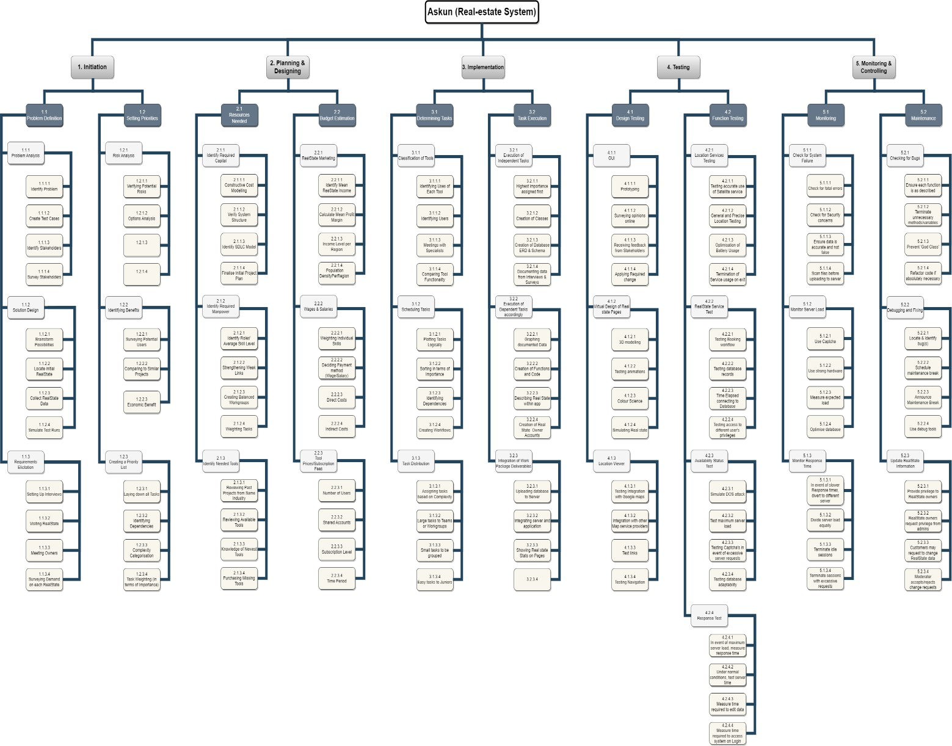

*Figure 1 WBS*

* + 1. **Gantt Chart**

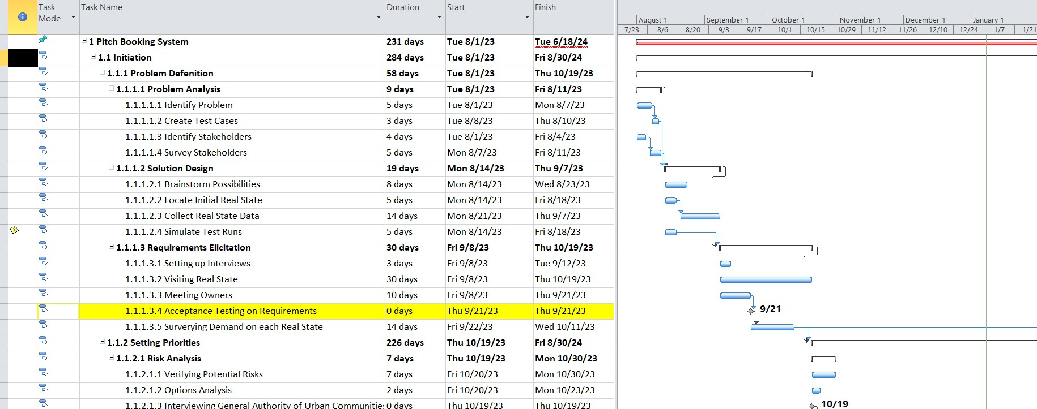

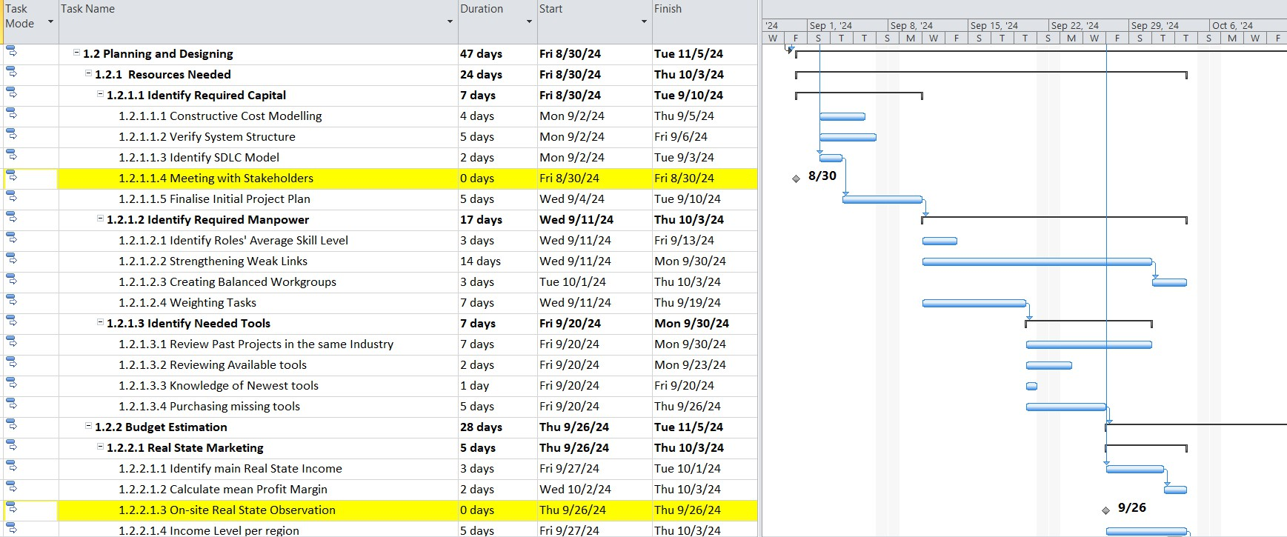

* + 1. **Prioritized Risk**

|  |  |
| --- | --- |
| **Ranking** | **Potential Risk** |
| 1 | Project Data Security - All Data must be Secure |
| 2 | Keeping Budget - Stay under budget |
| 3 | Portability - Allow system to run on all platforms without performance dip |
| 4 | Permissions - Users must not be allowed to access privileges not under their  user type |
| 5 | Missing Deadlines - Keep Project on Track |
| 6 | Creating Project Groups |
| 7 | Stakeholder pullout |
| 8 | Human Error or Misconduct |
| 9 | Extreme Events (Strike, Revolution, etc.) |
|  |  |

* + 1. **Pert Calculations**

|  |  |  |  |  |  |  |
| --- | --- | --- | --- | --- | --- | --- |
| Step | Start Date | End Date | Pessimisti c (Days) | Optimisti c (Days) | Realisti c (Days) | Duratio n (Days) |
| Acceptance Testing on Requirements | 16/9/2023 | 30/10/202  3 | 55 | 35 | 43 | 43 |
| Team Assembly | 8/1/2023 | 1/9/2023 | 30 | 15 | 21 | 21 |
| Meeting with Stakeholders | 2/9/2023 | 12/9/2023 | 15 | 10 | 12 | 12 |
| On-site RealState Observation | 15/4/2024 | 6/1/2023 | 50 | 30 | 43 | 44 |
| Finalise Teams until End of Project Period | 6/1/2024 | 6/23/2024 | 25 | 10 | 15 | 15 |
| Random User Testing System (On-Site) | 26/11/202  3 | 3/6/2024 | 35 | 25 | 32 | 32 |
| External Audit and Testing of System | 4/4/2024 | 4/9/2024 | 7 | 4 | 5 | 5 |
| External Audit and Testing of System | 5/1/2023 | 18/5/2023 | 20 | 10 | 17 | 17 |
| Iteration Test Drive |  |  |  |  |  |  |

**1.6.7 Milestone Report**

|  |  |  |  |  |
| --- | --- | --- | --- | --- |
| **Milestones** | **Date** | **Status** | **Responsible** | **Issues/Comments** |
| Acceptance Testing on  Requirements | 16/9/2023 | - |  | Report feedback from  stakeholders |
| Team Assembly | 1/8/2023 | - |  | Assemble teams with weights |
| Meeting with  Stakeholders | 2/9/2023 | - |  | Recap of project progression |
| On-site Real state Observation | 15/4/2024 | - |  | Open day to view and understand nature of Real-  estate |
| Finalise Teams until End  of Project Period | 1/6/2024 | - |  | Teams are non-negotiable  after this stage |
| Random User Testing  System (On-Site) | 26/11/2023 | - |  | Picking random people on site  to test system |
| External Audit and  Testing of System | 4/4/2024 | - |  | Hiring external testing  organisation to test system |
| Push System to General  Public | 15/5/2024 | - |  | Release to App Store and  Google Play Stores |
| Iteration Test Drive |  | - |  | Start of testing as a final  product |

##### 1.7 Document Structure

The project document is organized into four chapters, each focusing on specific aspects of the real estate management system. Additionally, the document includes a conclusion, future work, and a references section

Chapter 1: Introduction

Introduction to the real estate management system, outlining its scope, objectives, challenges, constraints, assumptions, risks, and project planning.

Chapter 2: Market Analysis and Related Work

An in-depth analysis of the market using the 4 Ps, SWOT analysis, PESTEL analysis, examination of related projects, related work, and identification of research gaps.

Chapter 3: Methodology and Proposed Work

Introduction to the project methodology, including data gathering, intended users, system functionality, system design (architecture, use cases, class and sequence diagrams), and a prototype of the system interface.

Chapter 4: Conclusion and Future Work

Summarizes key findings and outcomes, followed by discussions on potential future enhancements and developments.

References

List of all sources and references cited in the document.

C h a p t e r T w o

# MARKET ANALYSIS & RELATED WORK

#### INTRODUCTION

Before embarking on our journey to build ASKUN, the revolutionary real estate platform, we must first understand the terrain we're navigating. This chapter unravels the intricate tapestry of the current real estate market, analyzing its vibrant threads, tangled knots, and shimmering opportunities.

##### 4Ps

Product:

**Unpacking the Powerhouse:**

* + - **AI-Powered Valuations:** Go beyond guesswork with hyper-accurate estimations informed by real-time market data and property-specific attributes. Empower buyers with confidence and sellers with optimal negotiation leverage.
    - **Personalized Recommendations:** Ditch the information overload! Leverage machine learning to match users with properties that align with their unique needs, budgets, and lifestyle preferences. Save time, reduce frustration, and discover dream homes faster.
    - **Immersive 3D Tours:** Step into virtual reality! Explore properties remotely with detailed 3D tours that capture every corner and nuance. Eliminate travel logistics and experience homes like never before, whether across town or across the globe.
    - **Blockchain Secure Transactions:** Build trust and transparency with blockchain technology. Securely manage financial transactions, eliminate fraud risks, and streamline the closing process for a seamless and worry-free experience.
    - **Data-Driven Market Insights:** Gain a tactical edge! Access real-time market trends, neighborhood analyses, and predictive forecasts to make informed investment decisions. Optimize your property search or maximize your listing's impact with data-backed strategies.

Benefits Beyond Compare:

* + - **Effortless Property Search:** Say goodbye to endless scrolling and frustrating searches. Find your perfect property quickly and easily with intuitive filters, personalized recommendations, and advanced search tools.
    - **Empowered Decision-Making:** Equip yourself with the knowledge and confidence to make informed choices. Accurate valuations, market insights, and detailed property information guide you every step of the way.
    - **Streamlined Transactions:** Navigate the complexities of real estate with ease. Secure blockchain transactions, efficient communication tools, and streamlined processes expedite the journey from initial contact to closing.
    - **Unmatched Transparency:** Eliminate uncertainty and build trust. Blockchain technology ensures secure and transparent financial transactions, while detailed property information and open communication foster peace of mind.
    - **Convenience and Control:** Access everything you need on your terms. Our user-friendly website and mobile app put the power of property exploration and transaction management at your fingertips, anytime, anywhere.

Quality is King:

* + - **Intuitive Interface:** Navigate seamlessly with a user-friendly interface designed for all levels of tech-savviness. Find what you need quickly and easily, whether you're a seasoned investor or a first-time buyer.
    - **Reliable Data:** Trust the power of accurate and up-to-date information. We prioritize data quality and integrity to ensure every recommendation, valuation, and market insight is trustworthy and actionable.
    - **Secure Technology:** Your data is our priority. We implement robust security measures and industry-leading technology to protect your personal information and financial transactions.
    - **Continuous Improvement:** We're constantly evolving! We value your feedback and utilize cutting-edge technology to refine our platform and deliver the best possible user experience.

##### Price:

The pricing strategy for ASKUN Real Estate Platform is designed to offer flexibility and value to different user categories:

* Guest Users:
  + **Free Access:** Basic features such as property search and general platform access will be provided at no cost to encourage user engagement.
* Registered Users:
  + **Subscription Tiers:**
    - *Basic Tier:* Users can subscribe to a basic tier with a monthly or annual subscription fee, granting access to advanced search features and personalized property recommendations.
    - *Premium Tier:* An enhanced subscription tier will be available, offering additional features such as priority customer support, exclusive property insights, and early access to new listings.
  + Transaction-Based Pricing:
    - Users engaging in property transactions will incur a small transaction fee, ensuring a sustainable revenue model for the platform.
* Real Estate Agents:
  + **Tiered Pricing Plans:**
    - *Standard Plan:* Real Estate Agents can opt for a standard plan with a monthly or annual fee, providing essential tools for property listing, marketing, and client management.
    - *Pro Plan:* A more advanced plan will be available, offering additional features like analytics, lead generation, and priority listing placement.

Finding the Perfect Fit:

* **Flexible Models:** Choose the option that suits your needs and budget. Consider free access with premium upgrades, tiered subscription plans with varying feature sets, or transaction fees for specific services.
* **Competitive Benchmarking:** We understand the market. Our pricing is carefully calibrated to offer exceptional value compared to competitors, ensuring you get the most bang for your buck.
* **Clear Value Proposition:** We believe in transparency. Every pricing tier is clearly defined, outlining the specific features and benefits you receive for your investment.

Place:

**Reaching You Wherever You Are:**

1. **SEO Domination:** Top the search engine results! We leverage strategic SEO best practices to ensure your ideal customers find our platform naturally when searching for relevant keywords.
2. **Social media:** Engage and connect on your favorite platforms. We maintain an active presence on relevant social media channels, sharing valuable content, building trust, and fostering a vibrant community.
3. **Content is King:** Inform and inspire with targeted content marketing. Our blog, articles, and infographics offer valuable insights, market trends, and expert advice, attracting organic traffic and establishing thought leadership.
4. **Industry Partnerships:** We collaborate for success. Partnering with key industry players like real estate associations, developer conferences, and technology events allows us to reach a wider audience and showcase our platform's unique value proposition.
5. **Accessibility for All:** Break down barriers! Our website is optimized for mobile devices, available in multiple languages (if necessary), and adapts to different screen sizes to ensure everyone can access our services easily.
6. **Building a Strong Brand:** We stand out from the crowd. We develop a distinct and memorable brand identity that resonates with our target audience and conveys our dedication to innovation and excellence.

Promotion:

**Amplifying Your Voice:**

1. **Leverage Influencer Marketing:** Partner with relevant real estate influencers, bloggers, and social media personalities to reach a wider audience and capitalize on their established trust. Host product reviews, giveaways, or exclusive collaborations to drive engagement and generate buzz.
2. **Interactive Webinars and Live Q&As:** Host informative and interactive webinars or live Q&A sessions featuring industry experts, market analysts, and successful users. Share valuable insights, showcase platform features, and answer audience questions in real-time, building trust and establishing your platform as a thought leader.
3. **Storytelling is Key:** Don't just tell them, show them! Create compelling video testimonials or success stories featuring real users who have benefited from your platform. Showcase their journeys, highlight problem-solving capabilities, and evoke emotional connections with your target audience.

Beyond the Usual Suspects:

* + **Partner with Local Businesses:** Collaborate with relevant local businesses like mortgage lenders, moving companies, or home improvement stores to offer exclusive discounts or bundled packages to your users. This expands your reach, provides added value, and fosters strategic partnerships.
  + **Gamification and Contests:** Inject a little fun! Leverage gamified elements like point systems, badges, or leaderboard rankings to encourage user engagement, incentivize platform exploration, and promote healthy competition. Host targeted contests with attractive prizes like free subscriptions, property tours, or consultation sessions.
  + **Viral Potential:** Think outside the box! Create unique promotional campaigns with shareable content or interactive elements that have the potential to go viral. This could involve user-generated content contests, humorous social media challenges, or interactive quizzes with valuable prizes.

Data-Driven Optimization:

1. **Track and Analyze:** Measure the effectiveness of your promotional efforts with website analytics, social media engagement metrics, and conversion rates. Identify what resonates most with your audience and adapt your strategies accordingly.
2. **A/B Testing:** Constantly refine your approach! Utilize A/B testing to compare different ad copy, landing page designs, or promotional offers to identify the most effective elements and optimize your campaigns for maximum reach and engagement.

##### SWOT Analysis Strengths:

* + 1. Unmatched reach and brand recognition:
       - Combined website traffic and social media following exceeding any other platform in the Egyptian market.
       - Strong recognition among both younger and older demographics, appealing to a wider range of users.
       - Potential for cross-promotion and increased visibility for complementary services like property management or mortgage lending.
    2. Enhanced user experience:
       - Seamless integration of existing user interfaces, retaining the best features of both platforms.
       - Advanced search and filtering functionalities, allowing users to quickly find their desired properties based on specific criteria.
       - Personalized recommendations and property alerts based on user preferences and search history.
       - Multilingual support to cater to the increasingly diverse needs of the Cairo market.
    3. Data-driven insights and innovation:
       - Access to a vast pool of combined data, enabling accurate market analysis and property valuation.
       - Development of AI-powered algorithms for personalized recommendations, dynamic pricing, and fraud detection.
       - Investment in virtual reality experiences and 3D property tours, providing immersive viewing options for users.
       - Integration with existing property management software and data analytics tools for increased efficiency and transparency.
    4. Market power and negotiating leverage:
       - Dominant market share attracts more developers, agencies, and service providers, leading to exclusive listings and competitive deals.
       - Ability to negotiate lower fees and commissions for users, offering cost-saving benefits.
       - Potential to influence market trends and pricing through data-driven insights and strategic partnerships.
    5. Stronger talent pool and expertise:
       - Combining the skills and experience of professionals from both platforms, creates a diverse and highly qualified team.
       - Opportunity for knowledge sharing and cross-training, fostering innovation and improving service quality.

##### Weaknesses:

1. Integration challenges:
   * Complexities of merging disparate IT systems, databases, and operational processes.
   * Potential for data migration errors and system downtime during the integration process.
   * Risk of losing user trust and loyalty if the transition is not handled smoothly.
2. Cultural differences and resistance to change:
   * Merging two teams with different work cultures and practices can lead to friction and conflict.
   * Effective communication and change management strategies are crucial to ensure employee buy-in and smooth integration.
   * Resistance from legacy users accustomed to the old platforms might require targeted communication and training initiatives.
3. Data accuracy and quality control:
   * Merging large databases can lead to duplicate listings, inconsistencies in data format, and inaccuracies in property information.
   * Stringent data verification procedures and continuous quality control measures are essential to maintain user trust and data integrity.
4. Brand identity and marketing challenges:
   * Successfully merging the branding of both platforms into a cohesive and recognizable new identity can be a complex task.
   * Clear communication and consistent messaging are crucial to avoid confusing users and diluting brand equity.
   * Effective marketing strategies are needed to reach new audiences and establish the merged platform as the leading real estate destination in Cairo.

##### Opportunities:

1. Expansion into new segments and markets:
   * Leveraging the combined resources and brand power to expand into new property segments like vacation rentals, commercial properties, or luxury real estate.
   * Expanding into new cities or neighboring countries, solidifying the platform's regional leadership position.
2. Developing a robust rental platform:
   * Dedicating resources to building a comprehensive and user-friendly rental section with dedicated marketing and search features.
   * Partnering with property management companies and landlords to offer a wider range of rental options and value-added services.
3. Building a strong community platform:
   * Fostering a vibrant community of buyers, sellers, and agents through online forums, events, and educational resources.
   * Developing tools and features for online collaboration and knowledge sharing between professionals and users.
   * Building brand loyalty and advocacy through community engagement and personalized interactions.
4. Embracing emerging technologies:
   * Investing in cutting-edge technologies like blockchain for secure property transactions, augmented reality for property visualization, and artificial intelligence for market analysis and price prediction.
   * Partnering with tech startups and innovation hubs to stay ahead of the curve and explore new opportunities in the real estate tech space.
5. Promoting sustainability and green initiatives:
   * Highlighting energy-efficient properties, promoting eco-friendly construction practices, and partnering with sustainability organizations.
   * Creating a dedicated section for green homes and attracting environmentally conscious buyers and sellers.

##### Threats:

1. Competition from local and international players:
   * Emergence of new competitors with innovative business models or aggressive marketing strategies.
   * Increased competition from international platforms entering the Egyptian market.
2. Shifting Economic Landscape:
   * **Economic downturn:** A potential economic slowdown in Egypt could significantly reduce demand for real estate, impacting transaction volume and platform revenue.
   * **Changes in government policies:** Policy changes affecting the real estate sector, such as tax regulations or building permits, could disrupt operations and hinder growth.
   * **Fluctuations in currency exchange rates:** Volatile currency exchange rates could impact overseas investments and property valuations, causing uncertainty for international buyers and sellers.
3. Technological Disruptions:
   * **Emergence of alternative housing solutions:** New models like co-living or micro-apartments could gain traction, challenging the traditional concept of homeownership and impacting demand for listed properties.
   * **Data security breaches:** Cyberattacks or data leaks could compromise sensitive user information, damaging trust and reputation, and potentially leading to legal repercussions.
   * **Reliance on third-party technology:** Dependence on external technology providers for critical functionalities could pose risks if those services are disrupted or become unreliable.
4. Legal and Regulatory Challenges:
   * **Changes in data privacy regulations:** Stricter data privacy laws could restrict data collection and sharing practices, hindering user personalization and marketing efforts.
   * **Disputes and legal claims:** Potential legal issues arising from inaccurate listings, fraudulent transactions, or property disputes could damage the platform's reputation and incur significant financial costs.
   * **Navigating local legal complexities:** Adapting to the specific legal landscape of Cairo and neighboring markets could be challenging, requiring careful compliance with regulations and potential licensing requirements.
5. Emerging Social and Environmental Trends:
   * **Changing buyer preferences:** Shifts in consumer priorities towards remote work, smaller living spaces, or eco-friendly housing could require the platform to adapt its offerings and marketing strategies.
   * **Natural disasters and climate change:** The potential for extreme weather events or other environmental risks could impact property values and disrupt market stability.
   * **Social unrest and political instability:** Political turbulence or civil unrest in Egypt could negatively impact investor confidence and hinder real estate transactions.

##### PESTEL analysis

* Political:
  + ***Regulations:* In Egypt**, real estate regulations include adherence to the "Unified Building Law": *The unified construction Law in Egypt includes all decisions and general legislative provisions related to construction in the Real Estate sector. Its aim is controlling and regulating construction via ensuring that construction projects are compliant with the standards set by the decision-making authorities*. and compliance with zoning laws set by the Ministry of Housing. Property taxes, such as the Real Estate Tax Law, must be considered for legal operations.

For example, suppose the Egyptian government imposes more taxes on the transfer of property or possession of land. The demand for real estate will fall, and the prices of land and property may fall too.

* + ***Political stability****:* With Egypt's stable political environment, real estate investors can invest. However, during political instability, investor confidence may lack, impacting the demand for properties.

in case of political instability, investors wouldn’t have enough confidence in the market, so the demand for real estate will fall.

* Economic:
  + ***Interest Rates****:* The Central Bank of Egypt's decisions on interest rates directly influence mortgage rates, affecting property demand. Shifts in the economy can impact real estate, and indicators like the *Gross domestic product* (GDP) growth rate and unemployment rates must be monitored.
* Social:
  + ***Demographics****:* Considering Egypt's diverse population, the website should tailor content to different age groups and income levels. The high population growth rate in certain areas directly correlates with increased demand and property prices.
  + ***Lifestyle Changes****:* The rise of remote work in Egypt influences property preferences, emphasizing the importance of home office spaces and high- speed internet connectivity.
* Technological:
  + ***Virtual Reality****:* Implementing 360-degree tech for property tours on the website can revolutionize the user experience, allowing potential buyers to explore homes remotely.
  + ***Chatbot Technology****:* Integrating Arabic-language chatbots enhances user engagement, providing instant support to users exploring the website. The effectiveness and integration of chatbot technology can impact user engagement and satisfaction.
  + ***Social media****:* Leveraging platforms like Facebook and Instagram is crucial for engaging with the Egyptian market. Social media can be used to showcase properties, gather customer feedback, and stay connected with potential buyers.

Investments in technology in the real estate sector allow people to pool their money to buy a collective property, the participation of people in the real estate industry has increased, and more people have started investing in the industry.

* Environmental:
  + ***Sustainability****:* Highlighting eco-friendly features in Egyptian properties, such as energy-efficient designs or solar panels, aligns with the increasing interest in sustainable living.
  + ***Climate Change****:* Considering Egypt's susceptibility to climate change, the website should provide information on how properties are flexible to environmental changes, influencing long-term property values.
* Legal:
  + ***Data Protection Laws****:* Adherence to Egypt's data protection laws, such as the Personal Data Protection Law, is crucial when handling sensitive information related to property transactions.
  + ***Environmental Laws****:* Respecting laws designating certain areas as protected or restricted is essential. Egypt designates specific lands as natural reserves, limiting commercial activities.
* Ethical:
  + ***Usability****:* Ensuring that the website is accessible to users with different abilities and providing Arabic language options promotes equal access to all types of people.

***Transparency****:* Ethical considerations involve providing clear and honest information about properties, prices, and transaction processes to build trust with potential buyers in the Egyptian market.

Market Size and Forecasts in Egypt:

* **Current value:** The Egypt Residential Real Estate Market size is estimated at USD

18.04 billion in 2023 and is expected to reach USD 30.34 billion by 2028.

* **Projected growth:** growing at a CAGR of 10.96% during the forecast period (2023- 2028). [1]
* **Regional breakdown:** Cairo dominates at 45% of market share, followed by Alexandria and other major cities.

Demand Drivers:

* **Population:** The Population in Egypt is expected to increase from 102 million people in 2020 121 million people by 2030 [2]
* **Urbanization:** Urban population reaching 70% by 2030, with Cairo attracting the highest influx [3]
* **Disposable income:** In Egypt the Middle-class growth drives purchasing power, especially for younger segments.
* **Government initiatives:** Subsidized housing programs, reduced interest rates, and mega-projects like New Administrative Capital.

Segmentation and Preferences: [4]

* **25-35:**
  + **Apartment sizes:** Average preference for 100-120 sqm units, with 54% favoring apartments and 28% townhouses in Egypt
  + **Locations:** Emerging areas like Sixth of October City and New Cairo offer affordability and connectivity.
  + **Rental market:** 80% rent, favoring flexible leases and modern facilities in convenient locations.
  + **Investment:** Limited involvement, primarily through family-owned properties or pooled funds.
* 35-45:
  + **Apartment sizes:** Average preference for 140-160 sqm units, with 62% seeking compound living for security and amenities
  + **Locations:** Established neighborhoods like Maadi and Sheikh Zayed with good schools and family-friendly amenities.
  + **Rental market:** 60% rent, prioritizing stable leases and competitive rates.
  + **Investment:** Active participants, seeking long-term wealth building through high- rental-yield properties or strategic projects.
* 45-60:
  + **Apartment sizes:** Luxury apartments exceeding 200 sqm or individual villas preferred.
  + **Locations:** Upscale areas like Zamalek or New Cairo, coastal destinations like the Red Sea for second homes.
  + **Rental market:** 40% rent, seeking low-maintenance options in secure communities with proximity to healthcare.
  + **Investment:** Diversification focus, exploring commercial properties, vacation rentals, and REITs.

Investment Trends:

* **Commercial:** Office spaces in Cairo CBD seeing high demand and yields. Retail outlets in prime locations and logistics warehouses also promising.
* **Vacation rentals:** Red Sea and North Coast experiencing significant growth, with Airbnb management gaining traction.
* **REITs:** Growing market with diversified offerings and yields between 7-9% [5].

Online Platforms:

* **PropTech adoption:** 75% of Egyptians use online platforms for property search [4].
* **Top platforms:** Aqarmap, Property Finder, OLX Egypt, with mobile apps dominating usage (80%).
* **Emerging trends:** Virtual tours, augmented reality, AI-powered recommendations, and crowdfunding platforms.

Cairo-Specific Data:

* **Average property prices:**
  + Apartments: EGP 15,000-25,000 per sqm in New Cairo, EGP 20,000-30,000 in Maadi.
  + Villas: EGP 35,000-50,000 per sqm in Sheikh Zayed, EGP 40,000-60,000 in New Cairo.
* Rental yields:
  + Apartments: 6-8% in central Cairo, 5-7% in New Cairo.
  + Villas: 5-7% in Sheikh Zayed, 4-6% in New Cairo.

Sustainability and Emerging Trends:

* Green building certifications are gaining traction, attracting eco-conscious buyers and investors.
* Rise of co-living spaces and shared ownership models catering to affordability and community living.
* Smart home technologies like automation and security systems are increasingly desired.

Buyer Personas for the Egyptian Real Estate Market (25-60 Age Group):

1. **The Young Professional (25-35):**
   * ***Demographics:*** Single or young couple, starting careers, rising income.
   * ***Needs*:** Affordable apartment in a well-connected, up-and-coming area. Modern amenities, flexible lease options, pet-friendly if applicable.
   * ***Priorities:*** Location, convenience, affordability, access to public transportation, social activities, and nightlife.
   * Information sources: Online platforms, social media, recommendations from friends and colleagues.
   * **Brands:** Property Finder, OLX Egypt, co-living spaces, developers offering flexible payment plans.
2. The Family Builder (35-45):
   * ***Demographics:*** Married couple with children, stable careers, growing family needs.
   * ***Needs:*** Larger apartment or townhouse in a family-friendly neighborhood with good schools, parks, and recreational facilities. Secure environment, reliable maintenance services.
   * ***Priorities:*** Safety, security, good schools, community amenities, spacious living, green spaces, potential for future expansion.
   * Information sources: Established real estate agencies, developer websites, recommendations from family and neighbors.
   * ***Brands:*** Aqarmap, developers with family-oriented projects, established compound

communities.

1. The Affluent Investor (45-60):
   * ***Demographics:*** High-income individuals, established careers, seeking luxury and investment opportunities.
   * ***Needs:*** Luxury apartment in a prime location with high-end finishes, security features, and exclusive amenities. Potential for second home or vacation rental property.
   * ***Priorities:*** Prestige, location, exclusivity, investment potential, rental yields, proximity to leisure and healthcare facilities.
   * ***Information sources:*** Private wealth managers, exclusive real estate agencies, luxury

property websites, investment reports.

* + ***Brands:*** International real estate firms, developers of luxury projects, high-end investment platforms.

1. Active Retirees (45-60):
   * ***Demographics:*** Retired or nearing retirement, children have moved out, seeking a smaller and manageable living space.
   * ***Needs:*** Smaller apartment or villa in a secure community with convenient access to healthcare and amenities. Low-maintenance living, potential for community activities.
   * ***Priorities:*** Security, healthcare proximity, community engagement, affordability, low maintenance, potential for downsizing and capitalizing on existing property.
   * Information sources: Senior-oriented communities, retirement planning websites,

recommendations from peers and family.

* + ***Brands:*** Senior living communities, developers offering smaller apartments and low- maintenance options, healthcare providers.

Real Estate Websites Usage Statistics:

**Global Trends:**

* + 97% of homebuyers use the internet in their home search. [6]
  + 73% of homebuyers used mobile or tablet devices to search for properties.
  + Online videos reach 92% of all internet users worldwide. [7]
  + Real estate listings with video receive 403% more inquiries than those without. [8]

Egyptian Specifics:

* + 75% of Egyptians use online platforms for property search. [4]
  + Top platforms: Aqarmap, Property Finder, OLX Egypt.
  + Age groups:
    - 25-35: Mostly renters, prioritize convenience and affordability.
    - 35-45: Seek family-friendly communities and good schools.
    - 45-60: Focus on luxury properties and investment opportunities.

|  |  |  |  |  |  |  |
| --- | --- | --- | --- | --- | --- | --- |
| **Common User Behaviors:**   * Compare prices and features across multiple websites. * Use virtual tours and online booking options. * Read reviews and ratings of properties and agents. * Contact agents through online forms or live chat. * Share listings with friends and family on social media.   **Emerging Trends:**   * Rise of AI-powered property recommendations. * Crowdfunding platforms for real estate investment. * Big data analytics to predict market trends and user behavior.   **2.4 Related Projects** | | | | | | |
|  | * 3D Scanning | | | | |  |
| *Company* | *Objective* | *Approach* | *Dataset* | *Results* |
| Vieweet | Make the real estate process more efficient and transparent | Uses a combination of machine learning, artificial intelligence, and big data | Real estate listings, public records, social media data, demographic data | Improves the real estate experience for both buyers and sellers |
| Matterport | Provide a high- fidelity, immersive experience of real estate properties | Uses 3D scanning technology | 3D scanned real estate properties | Increases the engagement of potential buyers and renters, improves the  efficiency of real estate agents |
| Tivoli theatre scans | system intends to provide an intuitive and interactive 3D building model, facilitating enhanced support for property developers, buyers, and sellers in the real estate  sector. | Uses 3D scanning technology and (CAD) methods | in-depth interviews with participants. The study collects insights and opinions. | lead to cost reduction, increased accessibility for Small and Medium-sized Enterprises and improved decision support across the real- estate industry. |
| * Blockchain | | | | |
| *Company* | *Objective* | *Approach* | *Dataset* | *Results* |
| Ubitquity | To create a secure and transparent platform for real estate  transactions. | Use blockchain technology to create a distributed ledger of property ownership records. | Data from public records and private sources. | Reduced transaction costs, increased transparency, and improved  security. |
| Propy | To streamline the real estate transaction process. | Use smart contracts to automate the execution of real estate contracts. | Data from MLS listings and other real estate sources. | Reduced paperwork, faster transaction times, and lower costs. |

|  |  |  |  |  |
| --- | --- | --- | --- | --- |
| RealBlocks | To create a fractional ownership platform for real estate. | Use blockchain technology to tokenize real estate assets. | Data from property appraisers and other real estate sources. | Increased access to real estate investment opportunities, improved liquidity, and greater transparency. |
| ShelterZoom | To improve the efficiency and transparency of real estate title  insurance. | Use blockchain technology to create a secure and tamper- proof record of title  transfers. | Data from title insurance companies and other real estate  sources. | Reduced fraud, improved title search accuracy, and lower costs. |
| StreetWire | To create a decentralized real estate data platform. | Use blockchain technology to create a secure and transparent repository of real estate data. | Data from public records and private sources. | Increased access to real estate data, improved data accuracy, and greater transparency. |
| Harbor | To tokenize real estate assets and make them more accessible to investors. | Use blockchain technology to create security tokens backed by real estate investments. | Data from real estate appraisers and other real estate sources. | Increased liquidity, diversification, and transparency. |
| SoluLab | To provide white-label solutions for real estate tokenization. | Help businesses tokenize their real estate assets and build custom blockchain applications. | Customized to the needs of the business. | Increased efficiency, security, and transparency. |
| ChromaWay | To enable the use of smart contracts in the real estate industry. | Build a platform that allows developers to create, deploy, and manage smart contracts for real estate transactions. | Supports the use of multiple blockchain networks. | Increased automation, efficiency, and security. |
| Propy Global | To provide a global platform for real estate transactions. | Use blockchain technology to facilitate cross-border  real estate transactions. | Enables the use of multiple currencies and payment methods. | Reduced friction, reduced costs, and increased transparency. |
| Polymath | To enable the creation of security token offerings (STOs) for real estate assets. | Build a platform that allows businesses to create and manage STOs for their real estate investments. | Provides a regulatory- compliant solution for real estate tokenization. | Increased liquidity and institutional investment. |
| BrikBit | To tokenize fractional ownership of real estate properties. | Build a platform that allows investors to purchase fractional shares of real estate properties. | Enables investors to diversify their portfolios and access previously inaccessible  investments. | Increased liquidity, reduced costs, and greater transparency. |

|  |  |  |  |  |  |  |
| --- | --- | --- | --- | --- | --- | --- |
|  | | | | | | |
|  | SafeWire | To provide a | Use blockchain | Facilitates secure | Reduced fraud |  |
|  | secure platform | technology to provide | and transparent | and increased |
|  | for real estate | secure escrow services | transactions. | trust. |
|  | transactions. | for real estate |  |  |
|  |  | transactions. |  |  |
| * SRE | | | | |
| *Company* | *Objective* | *Approach* | *Dataset* | *Results* |
| Zillow | Develop a | Utilize machine | Large database of | Accurate home |
|  | smart home | learning algorithms to | real estate | valuations that are |
|  | valuation | analyze a variety of | transactions | more predictive |
|  | system | factors, including |  | than traditional |
|  |  | property |  | methods |
|  |  | characteristics, market |  |  |
|  |  | trends, and |  |  |
|  |  | neighborhood data |  |  |
| Redfin | Enhance the | Employ artificial | Proprietary real | Increased user |
|  | home search | intelligence (AI) to | estate data and | engagement and |
|  | experience for | personalize property | customer | satisfaction, |
|  | buyers | recommendations and | behavior data | leading to more |
|  |  | provide real-time |  | successful |
|  |  | market insights |  | transactions |
| Trulia | Optimize the | Leverage AI to | Vast collection of | Improved listing |
|  | listing process | generate high-quality | property listings | effectiveness and |
|  | for sellers | property descriptions. | and historical | faster property |
|  |  | and suggest | sales data | sales |
|  |  | competitive pricing |  |  |
|  |  | strategies |  |  |
| Realtor.com | Provide a | Integrate AI-powered | Extensive real | Enhanced |
|  | comprehensive | tools for property | estate listings, | productivity and |
|  | real estate | search, market | agent | efficiency for |
|  | platform for | analysis, and | information, and | agents, leading to |
|  | agents and | transaction | market data | better customer |
|  | consumers | management |  | experiences |
| Homesnap | Streamline the | Utilize AI to connect | Large network of | Smoother home |
|  | home buying | buyers with qualified | real estate agents | buying experience |
|  | process for | agents, provide virtual | and extensive | with reduced |
|  | consumers | tours, and facilitate | property data | friction and |
|  |  | secure transactions |  | increased |
|  |  |  |  | transparency |
| Opendoor | Automate the | Employ AI to assess | Proprietary real | Faster and more |
|  | home buying | property values, | estate data and | convenient home |
|  | and selling | generate offers, and | transaction | buying and selling |
|  | process | manage the closing | history | experience |
|  |  | process |  |  |
| Offerpad | Provide a | Utilize AI to make | Large database of | Predictable and |
|  | seamless home | instant cash offers on | real estate | stress-free home |
|  | buying | properties, eliminating | transactions and | selling process for |
|  | experience for | the need for traditional | market trends | homeowners |
|  | sellers | showings and |  |  |
|  |  | negotiations |  |  |
| Knock | Streamline the | Employ AI to assess | Proprietary real | Increased |
|  | home buying | property values, | estate data and | certainty and |
|  | process for | generate pre-approval | financial | confidence for |
|  | contingent | letters, and facilitate | information | contingent buyers, |
|  |  | buyers | home inspections |  | leading to more |  |

|  |  |  |  |  |
| --- | --- | --- | --- | --- |
|  |  |  |  | successful transactions |
| Orchard | Simplify the home buying process for first-time buyers | Utilize AI to provide personalized recommendations, financial assistance, and mortgage options | Large database of first-time homebuyer data and market trends | Improved accessibility and affordability of homeownership for first-time buyers |
| Divvy | Revolutionize the homeownership experience | Employ AI to manage shared ownership of properties, enabling fractional ownership and unlocking access to real estate  investments | Proprietary blockchain technology and real estate data | Increased access to real estate ownership and diversified investment opportunities |
| Arrived | Democratize real estate investment | Utilize AI to identify and analyze potential real estate investments, enabling fractional ownership | Large database of real estate properties and market data | Increased access to real estate investment opportunities for a wider range of investors |

##### RELATED Work

Property Finder:

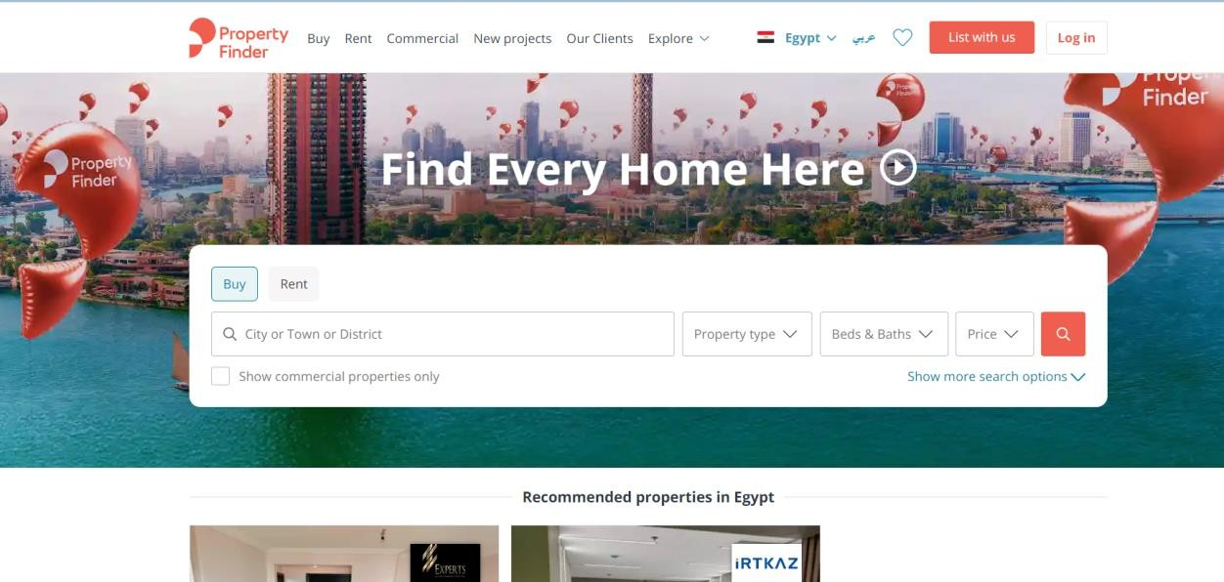

##### Bayut:

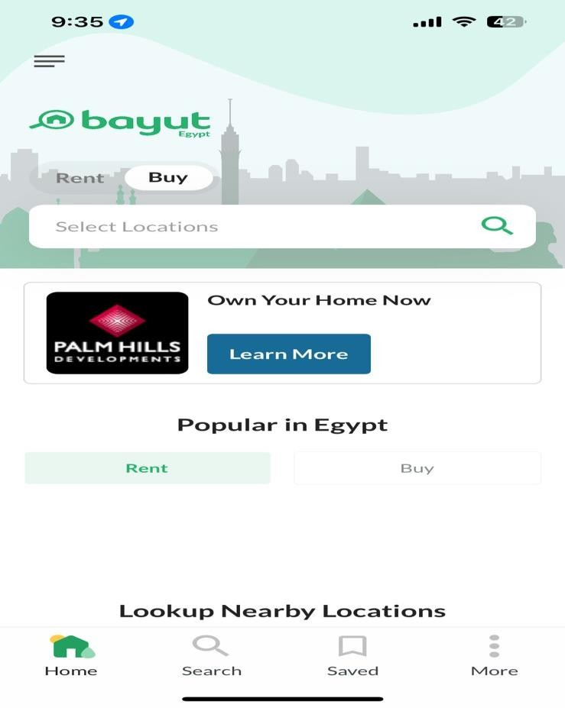

##### Research Gap

Research Gap 1: Implementation and Integration of Disruptive Technologies for Smart Real Estate Management

While various studies have identified potential disruptive technologies for smart real estate management, there is a lack of in-depth analysis and practical frameworks for their implementation and integration into existing real estate practices.

Research Gap 2: Empirical Validation of Risk Management Frameworks for Blockchain-Based Real Estate Transactions

Conceptual frameworks for managing risks in blockchain-based real estate transactions need to be tested and validated through empirical studies to assess their effectiveness in real-world scenarios.

Research Gap 3: Addressing Challenges and Regulatory Hurdles for Blockchain Adoption in Real Estate

Despite the potential benefits of blockchain technology in real estate, there are challenges and regulatory hurdles that hinder its widespread adoption.

**Research Gap 4: Ethical Considerations and Algorithmic Bias in Real Estate Chatbots** While real estate chatbots have the potential to enhance customer service and streamline real estate transactions, there are concerns about ethical implications and potential biases associated with these technologies.

Research Gap 5: "Providing Real-Estate Services through the Integration of 3D Laser Scanning and Building Information Modeling"

While the study discusses the potential benefits of integrating 3D laser scanning and building information modeling (BIM) for real estate services, it does not provide empirical evidence to quantify these benefits. Future research could conduct case studies or pilot projects to demonstrate the cost savings, efficiency improvements, and decision-making support that can be achieved through this integration.

Research Gap 6"Implementation of 360 videos and mobile laser measurement technologies for immersive visualization of real estate & properties"

Comparative Analysis of 360 Video Platforms and Features: Conduct a comprehensive comparison of different 360 video platforms, evaluating their features, ease of use, integration capabilities, and compatibility with VR devices.

Optimization of 360 Video Production for Real Estate: Investigate the optimal production techniques, lighting conditions, and camera angles for capturing high-quality 360 videos that accurately represent the property's features and ambiance.

Impact of 360 Videos on Property Perception and Decision-Making: Investigate the impact of 360 videos on potential buyers' perception of properties, their level of engagement, and their decision-making processes...

Accessibility Considerations for 360 Videos and MLM-Based Property Visualizations: Investigate accessibility considerations for 360 video tours and MLM-based property visualizations, ensuring that these technologies are inclusive and accessible to individuals with disabilities.

Privacy and Data Security in 360 Video and MLM Data Collection: Address privacy and data security concerns related to the collection, storage, and sharing of 360 video footage and MLM data.

* 1. The Engineering Standards:

*Web Accessibility Standards:*

* + - **W3C Web Content Accessibility Guidelines (WCAG) 2.1:** Ensures the real estate website's accessibility to people with disabilities, incorporating assistive technologies like screen readers.

*Real Estate Data Standards:*

* + - **Real Estate Standards Association (RESA) CADA Web Services Standard:** Defines a common interface for exchanging real estate data between systems, facilitating seamless integration with other platforms and third-party services.

*Quality Management Standards:*

* + - **International Organization for Standardization (ISO) 29001:2021 Quality Management Systems:** Provides a framework for implementing a quality management system, ensuring consistent delivery of high-quality products and services on the real estate website.

*Cybersecurity Standards:*

* + - **National Institute of Standards and Technology (NIST) Cybersecurity Framework:** Offers a comprehensive approach to cybersecurity risk management, safeguarding the real estate website and users from potential cyber threats.
    - **Open Web Application Security Project (OWASP) Top 10 Web Application Security Risks:** Identifies common and critical web application security vulnerabilities, guiding developers in securing the real estate website's code and infrastructure.

*3D Scanning and 360-Degree View Standards:*

* + - **ASTM E5766-16 Standard Practice for Generating Virtual Representations of Real Property Using 3D Scanning Technology:** Guides the use of 3D scanning for capturing accurate property models for virtual tours.
    - **International Organization for Standardization (ISO) 16757-1:2009 Information Technology -- Geometrical Product Specifications (GPS) -- Digital Product Definition -- Data Structures for 3D Representation:** Defines a common data structure for 3D product models, ensuring compatibility across software applications.

*Chatbot Standards:*

* + - **Association for Computing Machinery (ACM) Code of Ethics and Professional Conduct:** Provides ethical guidelines for the development and deployment of responsible chatbots.
    - **IEEE P7006/D7:2022 Standard Ethical Considerations in Artificial Intelligence Development:** Offers a framework for addressing ethical concerns in AI development, including those relevant to chatbots.

*Blockchain Technology Standards:*

* + - **IEEE P2416/D6.1:2022 Standard for Blockchain Terminology:** Establishes a common vocabulary for understanding blockchain technology.
    - **Hyperledger Fabric: An Open-Source Blockchain Framework:** A modular and scalable open-source platform suitable for secure blockchain-based solutions in real estate transactions.

C h a p t e r T h r e e

# METHODOLOGY & PROPOSED WORK

#### INTRODUCTION

In this chapter we will discuss the methodology behind the project and most importantly the Ways in which are needed to complete this project

#### METHODOLOGY

Requirement Analysis:

Conduct an extensive market analysis to discern prevailing trends and user preferences in the real estate industry. Engage with stakeholders, including real estate agents, buyers, sellers, and investors, to gather insights and specific requirements. Collaborate with technology experts to assess the feasibility and integration possibilities of blockchain, chatbots, 3D scanning, and Smart Real Estate (SRE) across both web and mobile applications.

Define Functional and Non-Functional Requirements:

Clearly outline functional requirements, encompassing features such as property listings, advanced search functionalities, user authentication, secure transactions through blockchain, chatbot-assisted customer support, and integration of 3D scanning for virtual property tours. Identify and specify non-functional requirements, including performance, scalability, security, and usability, ensuring that both the web and mobile platforms meet industry standards and user expectations.

Technology Stack Selection:

Evaluate and select the most suitable technologies for implementing blockchain, chatbots, 3D scanning, and Smart Real Estate features across both web and mobile applications. Consider factors like compatibility, security, and scalability when choosing the technology stack for the development of the real estate platform.

Prototyping and Mockups:

Develop wireframes and prototypes to visualize the user interface and overall user experience of both the web and mobile applications. Gather feedback from stakeholders and potential users to refine and enhance the design before moving into the development phase.

Agile Development:

Adopt an Agile development methodology to ensure flexibility, adaptability, and continuous improvement throughout the project lifecycle. Divide the project into sprints, with each sprint focusing on specific features and functionalities for both the web and mobile platforms, allowing for incremental development and regular feedback loops.

Integration of Advanced Technologies:

Implement blockchain technology for secure and transparent property transactions. Integrate chatbots to enhance user engagement, provide real-time assistance, and streamline customer support across both web and mobile applications. Utilize 3D scanning technology to create immersive virtual property tours for potential buyers and renters.

Testing and Quality Assurance:

Conduct rigorous testing, including unit testing, integration testing, and user acceptance testing, to ensure the reliability and functionality of both the web and mobile applications. Implement automated testing processes to expedite testing cycles and detect issues early in the development phase.

Deployment and Monitoring:

Deploy the real estate platform, comprising both web and mobile applications, in a controlled environment. Closely monitor the performance, security, and user feedback of both platforms. Implement monitoring tools to track user interactions, identify potential issues, and make data-driven improvements post-launch.

User Training and Support:

Develop user documentation and provide training sessions for real estate agents, buyers, sellers, and other stakeholders for both web and mobile applications. Establish a robust support system to address user queries, concerns, and feedback post-launch.

Continuous Improvement:

Collect user feedback and analyze platform analytics to identify areas for improvement. Iterate on both the web and mobile applications based on user insights, technological advancements, and emerging trends in the real estate industry. The development team aims to create a cutting-edge real estate platform that addresses the evolving needs of users in the digital era through this comprehensive methodology.

* + 1. DATA GATHERING

#### INTENDED USERS

Homebuyers:

**Needs:**

* + - * Comprehensive property listings
      * Transparent pricing and transaction processes
      * Virtual viewing experiences
      * Personalized property recommendations
      * Secure and efficient property purchase experience

Real Estate Agents:

**Needs:**

* + - * + Efficient property marketing and client management tools
        + Streamlined transaction processes.
        + Increased visibility and lead generation
        + Enhanced client communication

Property Investors:

**Needs:**

* + - * + Access to investment opportunities
        + Market insights and analytics
        + Fractional ownership options
        + Property management tools

Property Owners:

**Needs:**

* + - * + Efficient property listing and marketing.
        + Secure tenant screening and management
        + Streamlined rental processes.
        + Maintenance and repair coordination
    1. DATA GATHERING

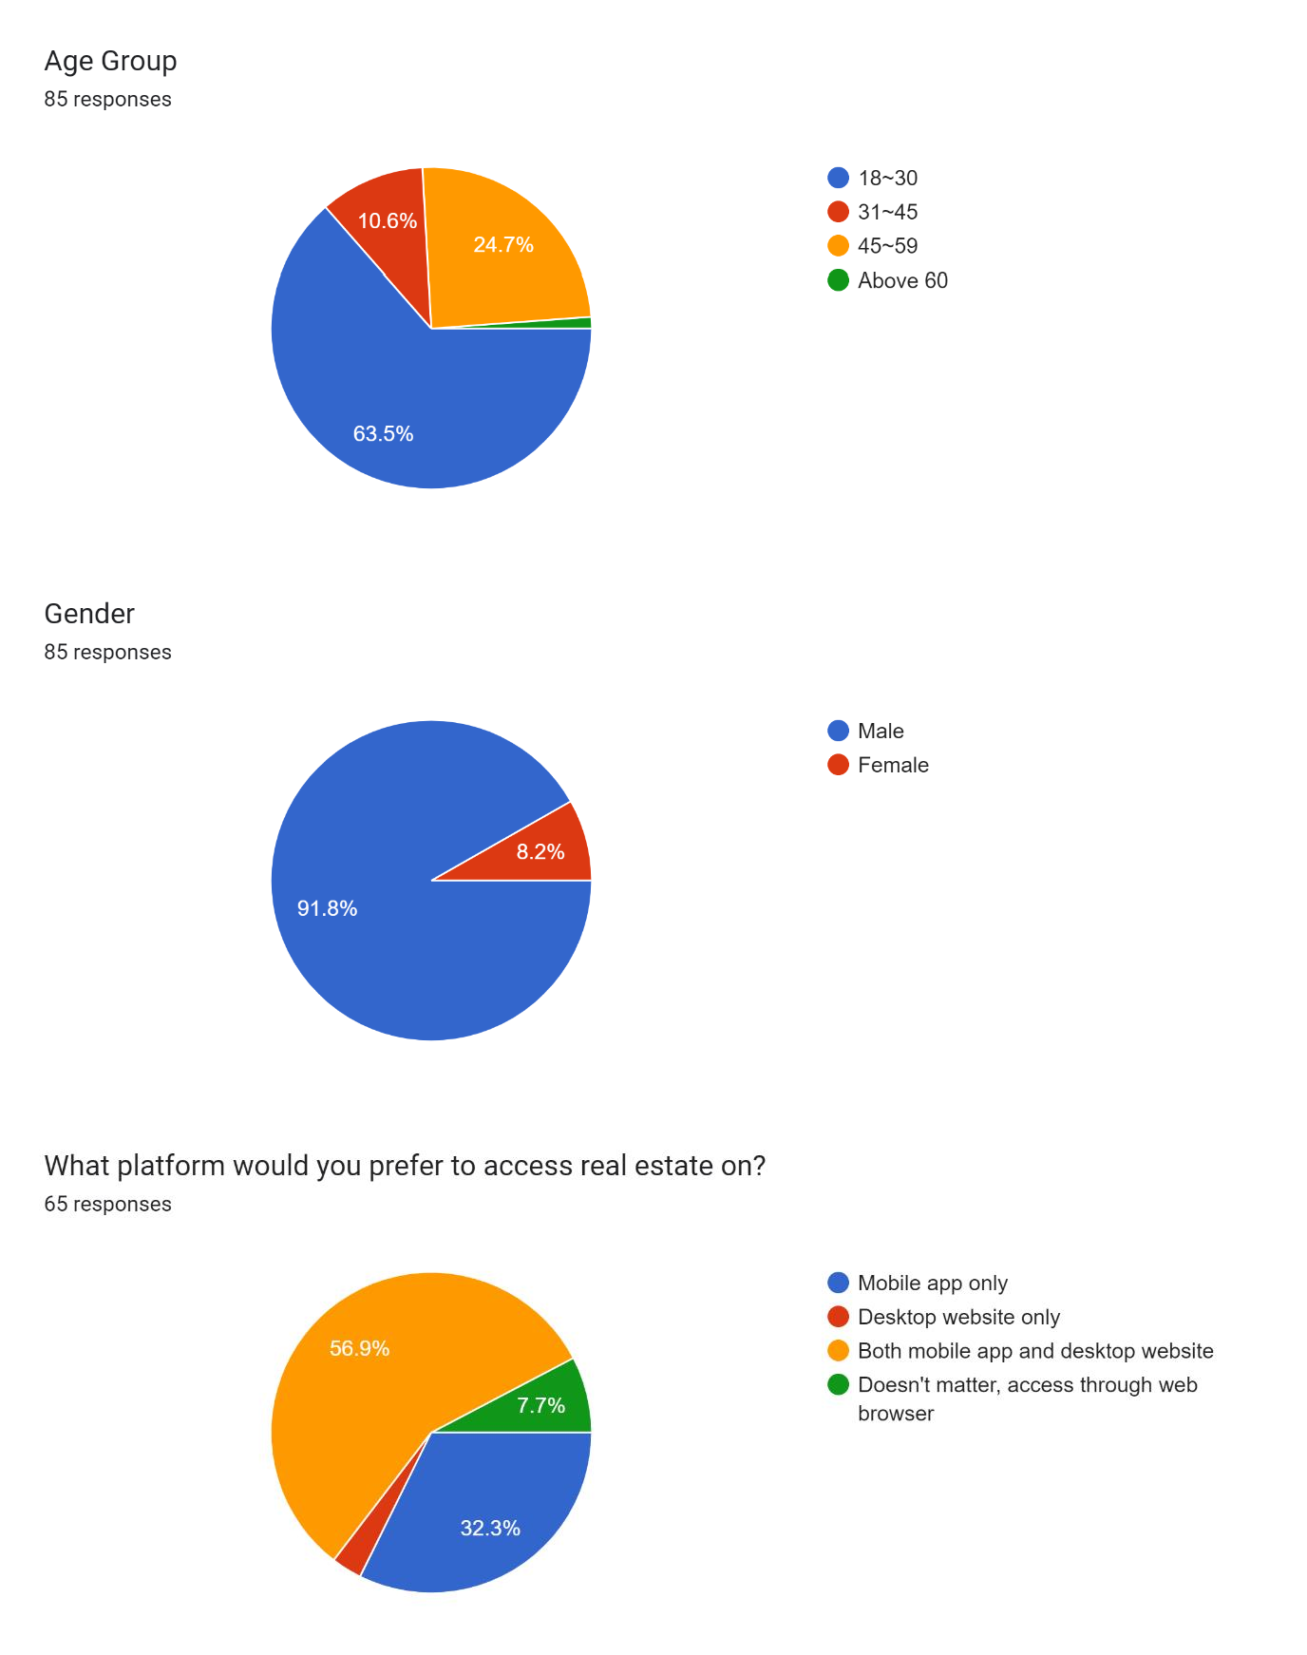

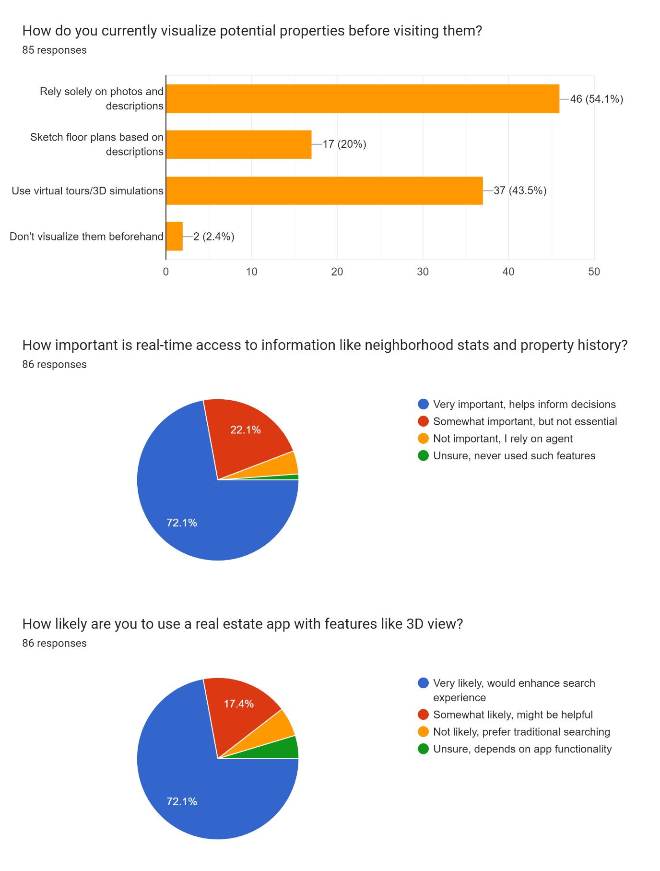

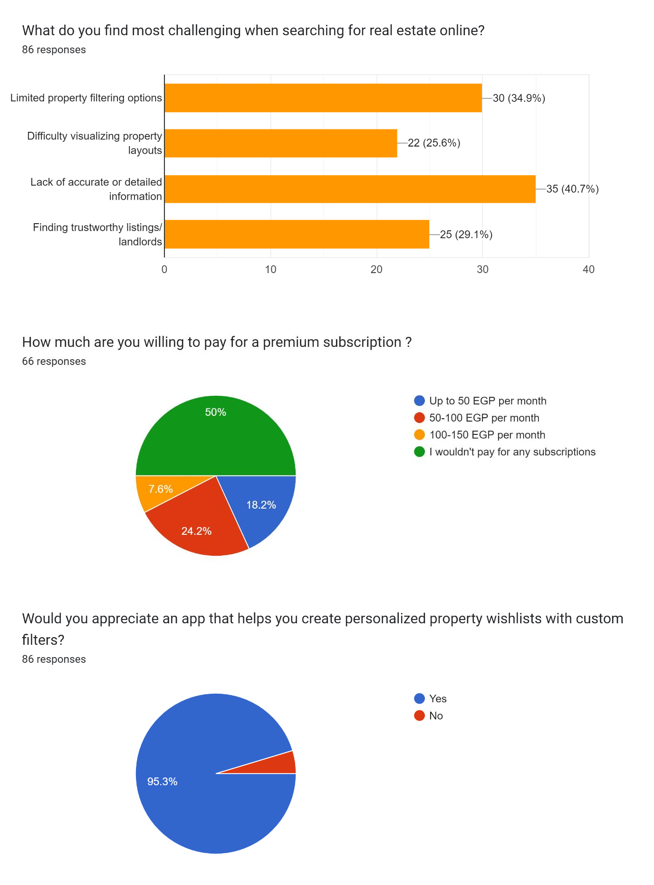

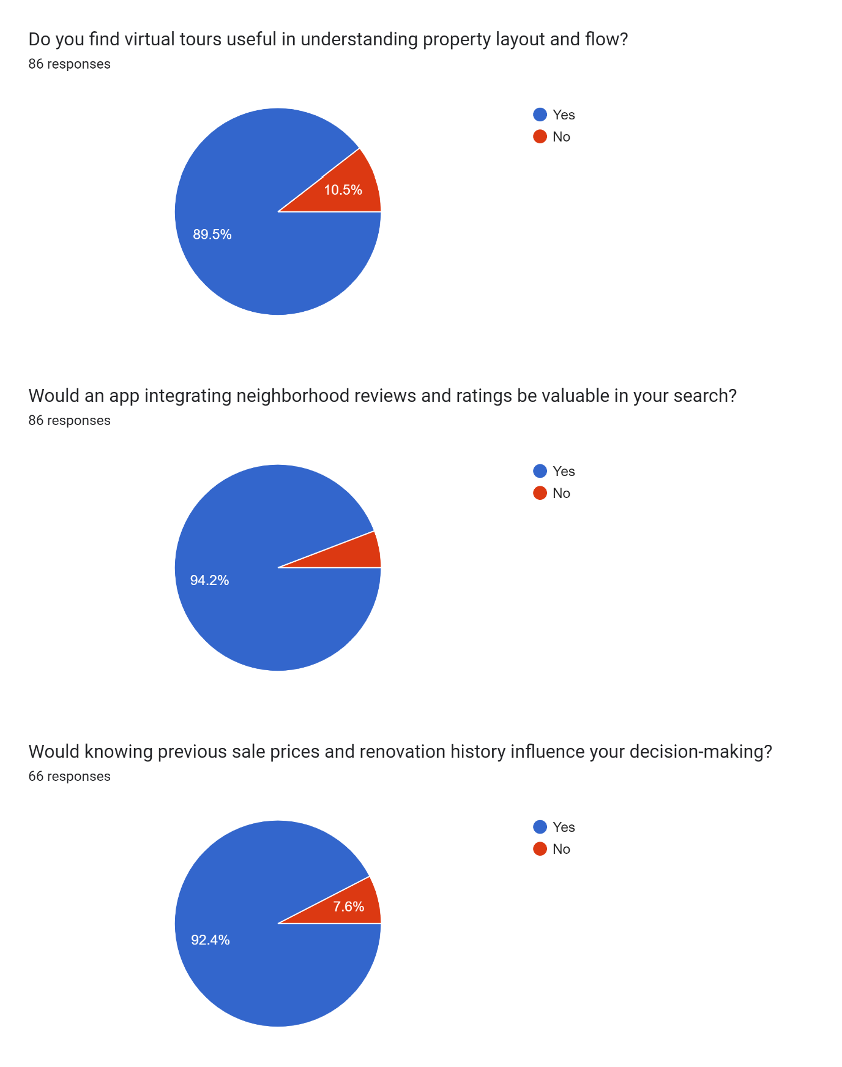

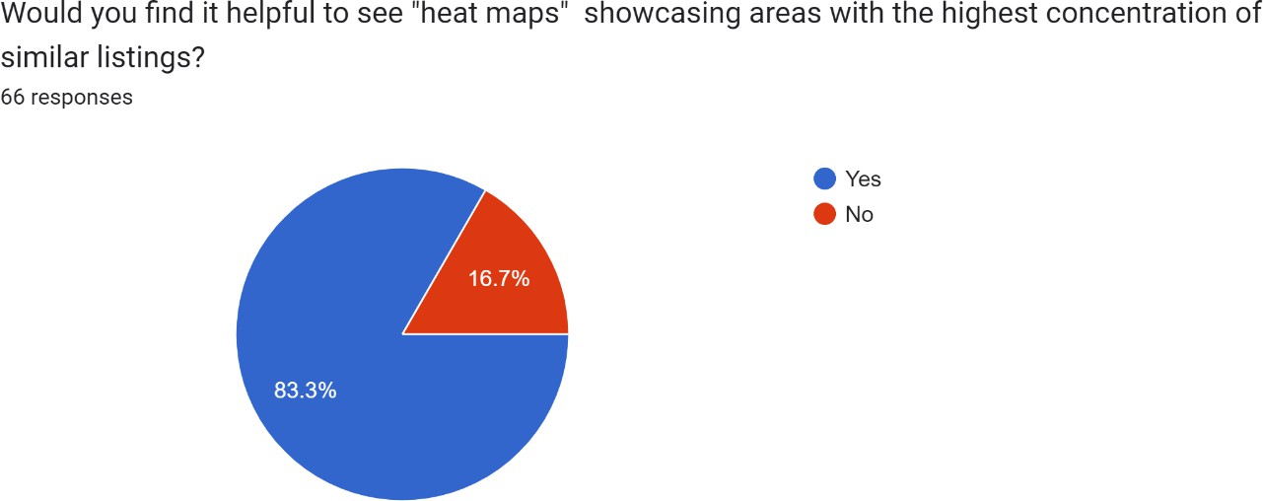

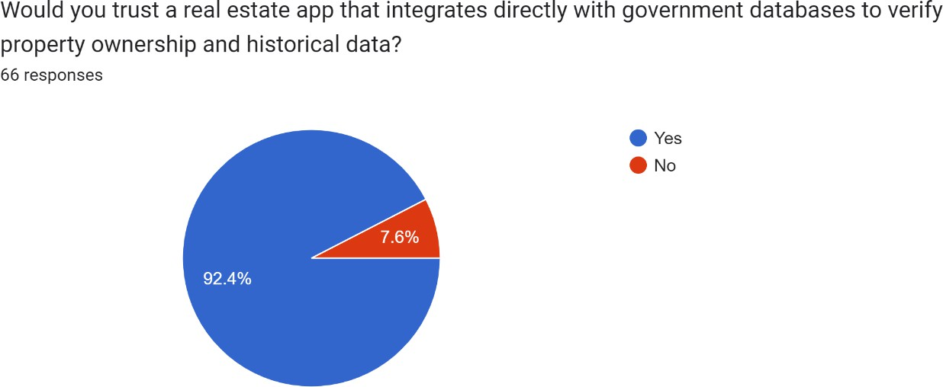

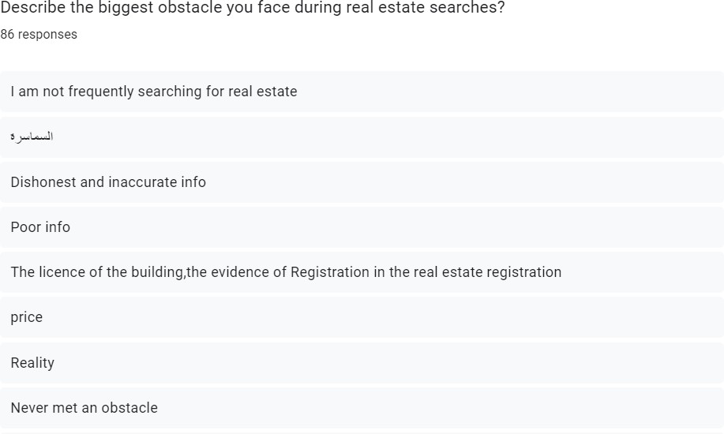

#### INTENDED USERS

Homebuyers:

**Needs:**

* Comprehensive property listings
* Transparent pricing and transaction processes
* Virtual viewing experiences
* Personalized property recommendations
* Secure and efficient property purchase experience

Real Estate Agents:

**Needs:**

* + Efficient property marketing and client management tools
  + Streamlined transaction processes.
  + Increased visibility and lead generation
  + Enhanced client communication

Property Owners:

**Needs:**

* + Efficient property listing and marketing.
  + Secure tenant screening and management
  + Streamlined rental processes.
  + Maintenance and repair coordination

#### PROPOSED MODEL

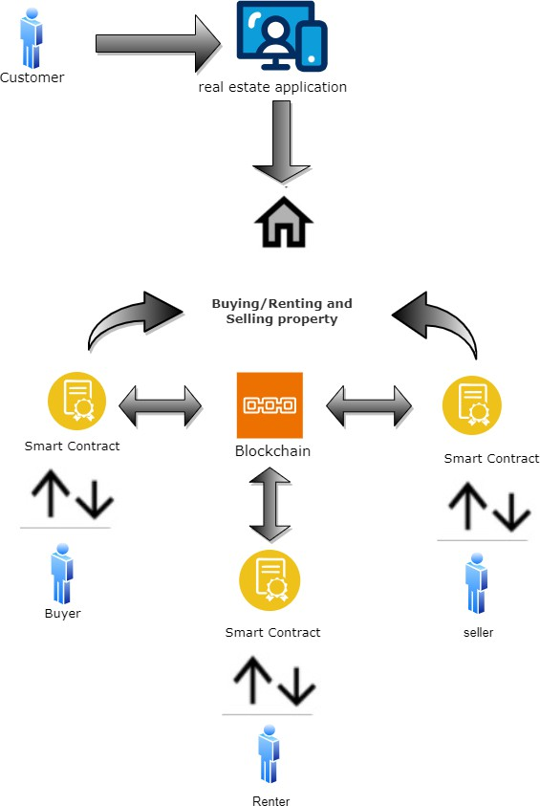In Smart real estate

*Figure 2 Block Diagram*

system (Askun), automated property marketplace powered by blockchain and smart contracts. Buyers, sellers, and renters connect through a real estate app, while the blockchain ensures transparent records and instant, error-free transactions. This reduces costs, streamlines processes, and boosts trust, but faces hurdles like technical complexity and evolving regulations. Exciting, but needs careful implementation.

#### SYSTEM REQUIREMENTS

##### Functional Requirements

**Admin Module:**

***User Management:***

* Assign different roles and permissions to admin users.
* Implement two-factor authentication for enhanced security.
* Track and log admin activities for audit purposes.

***Property Management:***

* Integrate AI-driven tools for property valuation and market analysis.
* Implement geospatial analysis for optimal property placement.
* Enable bulk property upload and management for efficiency.

***Listing Management:***

* Implement automated image recognition to ensure the quality of property images.
* Enable integration with third-party data sources for comprehensive property details.
* Implement an algorithm to suggest optimal listing prices based on market trends.

***Lead Management:***

* Integrate machine learning algorithms to prioritize leads based on conversion probability.
* Implement automated lead nurturing workflows for personalized communication.
* Utilize natural language processing for sentiment analysis of lead interactions.

***Reporting:***

* Provide customizable dashboards with real-time analytics.
* Implement predictive analytics for forecasting sales trends.
* Enable export of reports in various formats, including PDF and CSV.

***Sales Admin Dashboard:***

***Deal Tracking:***

* Implement a machine learning model for predicting deal success and potential risks.
* Enable automated document verification using OCR technology.
* Integrate blockchain for secure and transparent deal documentation.

***Sales Analytics:***

* Implement machine learning algorithms for dynamic pricing optimization.
* Utilize data visualization tools for interactive and exploratory data analysis.
* Integrate predictive analytics to forecast market trends.

***Lead Management:***

* Implement an AI-powered Chatbot for initial lead engagement.
* Enable lead scoring based on user behavior and interactions.
* Integrate with CRM systems for seamless lead tracking.

##### User Registration and Login:

***Registration:***

* Implement multi-factor authentication during the registration process.
* Enable social media login options for user convenience.

***Password Management:***

* Implement password encryption and salting for enhanced security.
* Enable biometric authentication for supported devices.

***Account Security:***

* Implement anomaly detection for unusual login patterns.
* Provide a password strength indicator during the password setup.

##### Bidding:

***Payment System:***

* Integrate multiple payment gateways for flexibility.
* Implement smart contracts using blockchain for transparent and secure transactions.

***Auction Listings:***

* Enable live bidding with real-time notifications.
* Implement dynamic bidding algorithms for fair pricing.

***Property Information:***

* Integrate augmented reality for virtual property tours before bidding.
* Implement image recognition for verifying property conditions.

##### Search and Filtering:

***Advanced Search:***

* Implement natural language processing for intuitive search queries.
* Enable voice-based search functionality.

***Property Recommendations:***

* Utilize machine learning algorithms for personalized property recommendations.
* Implement collaborative filtering for similar property suggestions.

##### Appointment Management:

***Calendar Integration:***

* Integrate with popular calendar applications for seamless scheduling.
* Implement automated reminders for scheduled appointments.

***Virtual Viewing:***

* Enable virtual reality experiences for remote property viewings.
* Implement live video streaming for real-time property walkthroughs.
* Support virtual tours of properties, allowing users to explore them remotely.
* Enable 3D visualization of property layouts and interior spaces.

##### User Feedback and Reviews:

***Sentiment Analysis:***

* Implement sentiment analysis on user feedback for continuous improvement.
* Provide incentives for users to leave detailed and constructive reviews.
* Allow users to leave comments and reviews for properties they have viewed.

***Interactive Ratings:***

* Enable users to rate specific features of a property individually.
* Implement a gamified system for encouraging user engagement in the feedback process.
* Implement a rating system to help users make informed decisions.

Map Integration:

***Augmented Reality Maps:***

* Implement augmented reality maps for a dynamic and interactive property search experience.
* Enable defending alerts for properties matching user preferences.
* Integrate map to location-based property search with interactive features.

***Community Insights:***

* Integrate with local community databases for additional insights into neighborhood amenities.
* Provide historical property price trends on the map.
* Integration with mapping services to provide visual representations of property locations.

##### Mobile Compatibility:

***Progressive Web App:***

* Implement a progressive web app for a seamless mobile experience.
* Enable offline functionality for users in areas with poor connectivity.

***Mobile-Specific Features:***

* Utilize device sensors for features like augmented reality and location-based services.
* Implement mobile-friendly UI/UX design for optimal user experience.
* Ensure that the system is accessible and easy to use on mobile devices.

##### Social Integration:

***Social Collaboration:***

* Integrate with social media analytics for targeted property promotions.
* Allow users to share real estate listings on social media platforms.

***Social Authentication:***

* Implement social media login for seamless account creation.
* Enable users to share their favorite properties on social media platforms.

##### Security Measures:

***Blockchain Security:***

* Implement blockchain for secure user data storage and transactions.
* Enable cryptographic hashing for sensitive data protection.
* Implement measures to protect user data and sensitive property.

***Penetration Testing:***

* Regularly conduct penetration testing to identify and address security vulnerabilities.
* Implement a bug bounty program for external security assessments.

##### User Profile Management:

***Personalized Dashboards:***

* Provide users with customizable dashboards based on their preferences.
* Enable dark mode and light mode options for personalized user interfaces.
* Enable users to create and manage their profiles, including personal information and preferences.

***Preference Analytics:***

* Analyze user behavior to suggest personalized property recommendations.
* Implement machine learning for predicting user preferences over time.
* Profile management enables users to update their profiles, including contact information and preferences.

##### Financial Calculators:

***Dynamic Calculators:***

* Provide dynamic calculators that adjust based on real-time market conditions.
* Implement scenario analysis for potential financial outcomes.
* Mortgage Calculator provides a tool for users to estimate mortgage payments based on property details.

***Integration with Financial Institutions:***

* Collaborate with banks for real-time interest rates and mortgage terms.
* Implement secure APIs for financial data exchange.
* Tax and insurance estimators combine tools to estimate property taxes and insurance costs.

##### Legal Compliance Checks:

***Regulatory Compliance Integration:***

* Integrate with government databases for real-time compliance checks.
* Implement automated checks for changes in local real estate regulations.

***Smart Contracts:***

* Utilize smart contracts on blockchain for automated compliance adherence.
* Implement a decentralized identity system for secure user verification.
* Perform verifications to ensure that property listings and transactions comply with local real estate laws and regulations (blockchain).

##### Non-Functional Requirements

1. Performance:
   * The system should provide responsive user interfaces with page load times not exceeding 3 seconds.
   * The backend should handle a minimum of 1000 simultaneous user sessions without degradation in performance.
   * Database queries should be optimized to ensure quick retrieval of data.
2. Training:
   * Training programs must be developed for system users, including administrators, agents, and customers.
   * Continuous training and support should be available to keep users informed about new features and updates.
3. Performance Standards:
   * Response times for critical operations, such as property search and transaction processing, should meet predefined performance standards.
   * Minimum system availability percentages should be established and maintained.
4. Backup and Recovery:
   * Regular automated backups of the system data should be performed.
   * A robust disaster recovery plan must be in place to minimize downtime in case of data loss or system failure.
5. Data Retention:
   * Define policies for data retention and archival, ensuring compliance with legal requirements.
   * Implement mechanisms to securely delete or anonymize user data upon request.
6. Third-Party Integration:
   * Specify requirements for third-party services and APIs to ensure seamless integration.
   * Regularly assess and update integrations to maintain compatibility with external systems.
7. Internationalization and Localization:
   * The system should support multiple languages and currencies to cater to a diverse user base.
   * Localization features should adapt the system to different cultural norms and legal requirements.

##### Quality

1. Reliability:
   * The system should consistently perform its intended functions accurately and reliably.
   * Reliable data storage and backup mechanisms should ensure data integrity and availability.
2. Performance Efficiency:
   * The system should provide efficient and responsive user interfaces, minimizing latency.
   * Backend processes, including property search and transaction processing, should be optimized for speed.
3. Scalability:
   * The architecture should support the ability to scale horizontally to handle increased user and data loads.
   * Scalability should be easily achieved by adding more resources or servers to the system.
4. Security:
   * Robust security measures should safeguard user data, transactions, and sensitive information.
   * Access controls, encryption, and secure communication protocols should be implemented.
5. Usability:
   * The user interface should be intuitive, user-friendly, and follow industry best practices in design.
   * Accessibility features should be incorporated to ensure usability for a diverse user base.
6. Maintainability:
   * The system's codebase should be well-organized, documented, and easy to maintain.
   * Regular code reviews and updates should facilitate ongoing system maintenance.
7. Availability:
   * The system should be available 24/7, with minimal downtime for maintenance and updates.
   * Redundancy and failover mechanisms should ensure continuous availability.
8. Portability:
   * The system should be deployable across different environments and cloud platforms.
   * Platform-independent components should facilitate ease of deployment.
9. Interoperability:
   * The system should seamlessly integrate with third-party APIs, services, and external databases.
   * Standardized data exchange formats should be used to enhance interoperability.
10. Privacy:
    * User privacy should be a priority, with mechanisms in place to protect personal data.
    * Compliance with data protection regulations and user consent for data processing should be ensured.

##### External interface Requirements

1. User Interfaces:
   * The system must provide a user-friendly web-based interface accessible through commonly used web browsers such as Chrome, Firefox, Safari, and Edge.
   * The interface design should be responsive and compatible with various screen sizes, including desktops, tablets, and smartphones.
2. Mobile Application:
   * Develop and maintain mobile applications for iOS and Android platforms.
   * Ensure consistency in functionality and user experience between the web interface and mobile applications.
3. Third-Party Integrations:
   * Implement APIs for seamless integration with external services, including payment gateways, CRM systems, and social media platforms.
   * Provide documentation for third-party developers to integrate their services with the real estate management system.
4. Calendar Integration:
   * Integrate the system with popular calendar applications, such as Google Calendar and Microsoft Outlook, to facilitate appointment scheduling.
   * Implement two-way synchronization to ensure updates made in external calendars reflect in the real estate system and vice versa.
5. Financial Institutions Integration:
   * Collaborate with banks and financial institutions to integrate real-time interest rates, mortgage terms, and other financial data.
   * Develop secure APIs for exchanging financial information and conducting transactions.
6. Mapping Services Integration:
   * Utilize mapping services for location-based features, such as property search and augmented reality maps.
   * Integrate with popular mapping platforms to provide visual representations of property locations.
7. Social Media Integration:
   * Implement social media login options for user convenience during the registration and login processes.
   * Enable users to share real estate listings and collaborate on property shortlisting through social media platforms.
8. Blockchain Integration:
   * Integrate blockchain for secure user data storage, transparent transactions, and smart contract execution.
   * Collaborate with blockchain networks to ensure compatibility and adherence to security standards.
9. Augmented Reality and Virtual Reality:
   * Enable augmented reality (AR) for dynamic and interactive property search experiences.
   * Facilitate virtual property tours through virtual reality (VR) features, supporting devices like VR headsets.

##### System features Design constrains.

1. Compliance with Local Regulations:
   * The system design must adhere to local real estate laws and regulations in all regions of operation.
   * Regular updates to the system should be efficiently implemented to accommodate changes in legal requirements.
2. Compatibility with Multiple Devices and Browsers:
   * Ensure compatibility with a diverse range of devices, browsers, and operating systems.
   * Design constraints include addressing variations in screen sizes, resolutions, and input methods.
3. Data Privacy and Security:
   * Implement robust data encryption and protection mechanisms to ensure user privacy.
   * Comply with data protection laws and industry standards regarding the storage and handling of sensitive user information.
4. Blockchain Integration Limitations:
   * Design constraints related to integrating blockchain technology include network transaction speeds and scalability.
   * Consideration should be given to the potential impact on system performance during periods of high transaction volume.
5. Dependency on External Services:
   * The system relies on various external services, such as mapping, social media, and financial institutions.
   * Design constraints involve managing service dependencies and ensuring continuous compatibility with evolving third-party APIs.
6. Mobile Platform Limitations:
   * Mobile applications need to consider the limitations of mobile devices, such as processing power, memory, and storage.
   * Optimize the mobile application design for efficient performance across a range of devices.

#### SYSTEM ANALYSIS

##### Database Design/ ERD

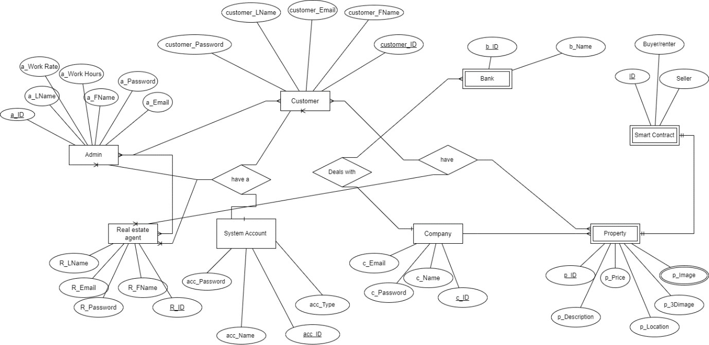

*Figure 3 ERD*

##### System Class Diagram

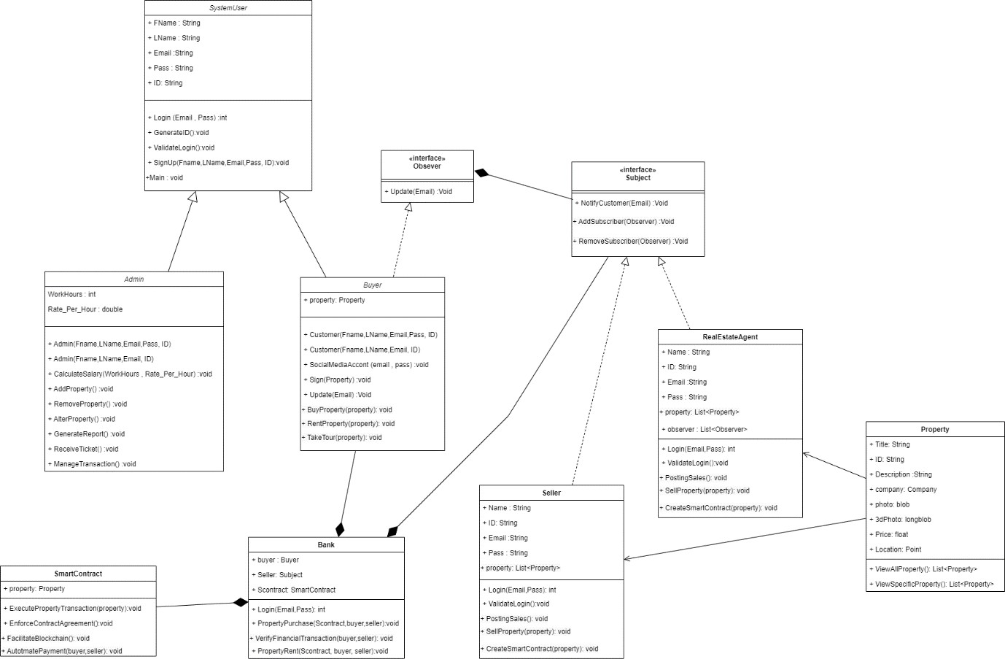

*Figure 4 Class Diagram*

Smart real estate system (Askun) has various user types (admins, buyers, agents, companies) managing and transacting properties. It uses smart contracts for secure ownership transfers and integrates with a bank for financial operationsو design patterns are implemented one of these patterns (observer pattern) that keeps users informed of updates. In essence, it offers a secure and automated platform for buying, selling, and managing properties.

##### Use Cases

**Full System Use case**

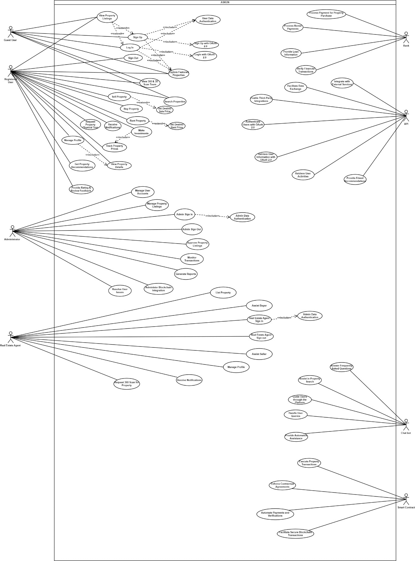

*Figure 5 USE CASE*

**Chat bot use Case**

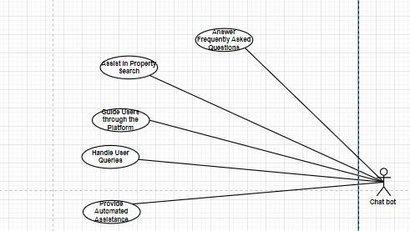

*Figure 6 Chatbot*

In the use case of Smart real estate system (Askun) This section of the use case diagram shows how chatbot can help users by answering their questions and provide automated assistance.

**Bank use Case**

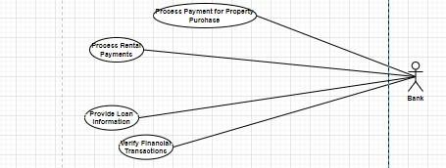

*Figure 7 Bank Use Case*

Buying property involves searching, negotiating, and finalizing the deal. The bank steps in to handle the financial aspect, ensuring smooth payment processing between buyer and seller. Think of it as a financial handshake sealing the purchase.

**Api use Case**

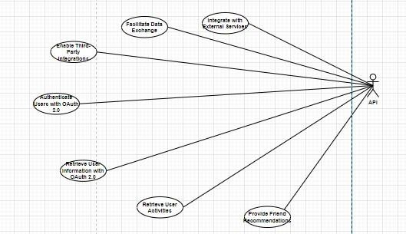

*Figure 8 API Use Case*

In the use case of Smart real estate system (Askun) This section of the use case diagram shows how API can authenticate users, retrieve user information, and facilitate data exchange, we also can take API from other companies that wants to be integrate with our system.

**Admin use Case**

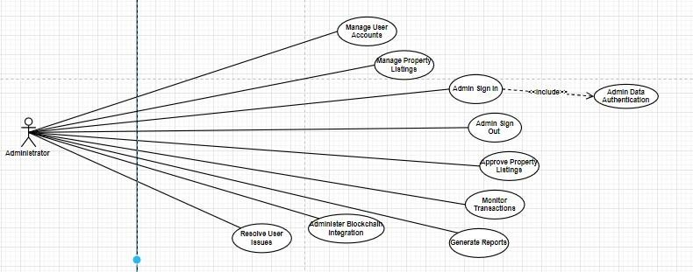

*Figure 9 Admin*

In the use case of Smart real estate system (Askun) This section of the use case diagram shows how Admin manage user profile, and property list, also it can track the transaction of payment and generate reports, also admin can receive tickets of issues that face the users of system and work to solve it.

**Real estate agent use Case**

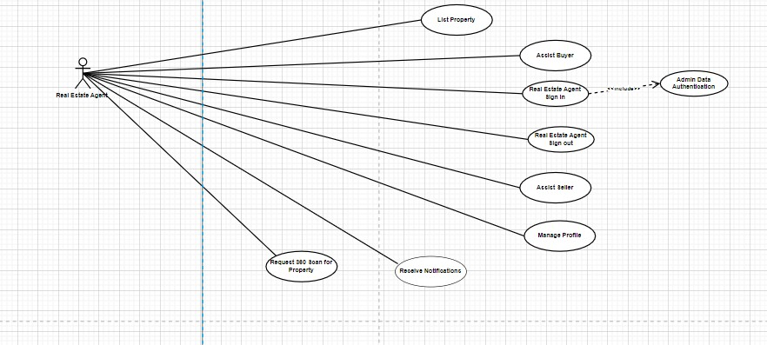

*Figure 10 Real estate Agent*

The real estate agent acts in the use case of Smart real estate system (Askun) as a trusted partner, guiding buyers with personalized searches and negotiations, while showcasing and managing listings for sellers, all within the platform's ecosystem. Essentially, they simplify transactions for both sides.

**User (Guest, Registered) Use Case**

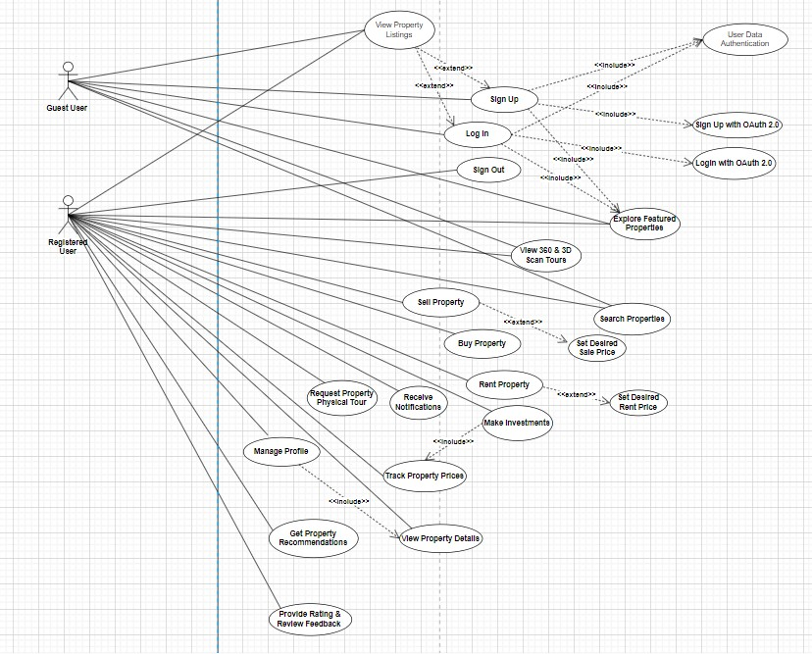

*Figure 11 User (Guest, Registered)*

In the use case of Smart real estate system (Askun) This section of the use case diagram shows how users manage their profiles, including updating details and viewing property info. They can also contribute ratings and reviews.

##### Detailed Use Case

1. **Sign Up with OAuth 2.0**

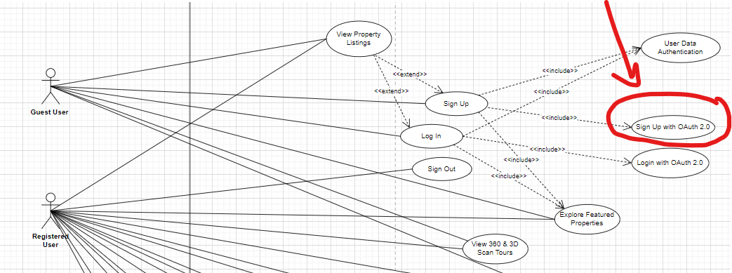

*Figure 12 Sign Up with OAuth 2.0*

|  |  |
| --- | --- |
| **Use Case** | Sign Up with OAuth 2.0 |
| **Triggering Event** | Guest User selects "Sign Up with (Facebook, Google, Apple)" |
| **Description** | Enables Guest User to sign up using OAuth 2.0 authentication. |
| **Primary Actor(s)** | Guest User |
| **Objects Involved** | Web App, Mobile App, Authentication Service, User Database |
| **Stakeholders** | Guest User,  Real Estate Agent, Administrator. |
| **Pre-condition** | Web / Mobile App is operational, Authentication Service is connected. |
| **Post-condition** | Guest User has a registered account. |
| **Flow of Activity** | 1. Guest User selects "Sign Up with (Facebook, Google, Apple)" 2. Web App /Mobile redirects to the Authentication Service. 3. Guest User authorizes with OAuth provider. 4. Authentication Service creates a new user account. |
| **Alternate Flows** | Guest User cancels OAuth authorization: Web /Mobile App notifies Guest User.  OAuth provider denies authorization: Web App notifies Guest User. |

##### Login With OAuth 2.0

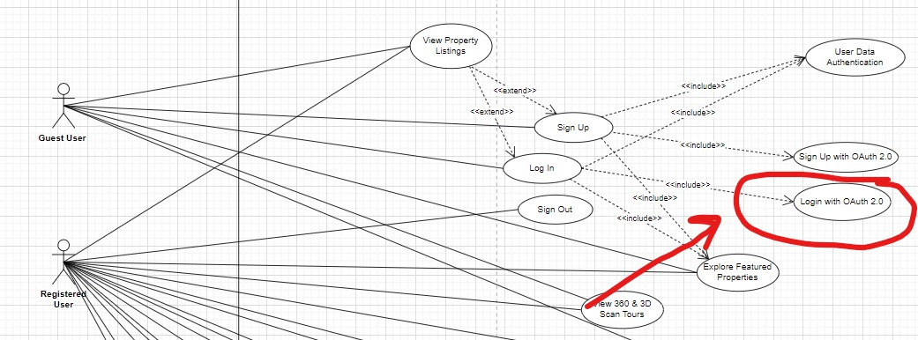

*Figure 13 Login with OAuth 2.0*

|  |  |
| --- | --- |
| **Use Case** | Log in with OAuth 2.0 |
| **Triggering Event** | Guest User selects " Log In with (Facebook, Google, Apple)" |
| **Description** | Allows Guest User to log in using OAuth 2.0 authentication. |
| **Primary Actor(s)** | Guest User |
| **Objects Involved** | Web App, Mobile App, Authentication Service, User Database |
| **Stakeholders** | Guest User,  Real Estate Agent, Administrator, |
| **Pre-condition** | Web / Mobile App is operational, Authentication Service is connected, Guest User has a registered account. |
| **Post-condition** | Guest User is logged in. |
| **Flow of Activity** | 1. Guest User selects "Log in with OAuth 2.0." 2. Web / Mobile App redirects to the Authentication Service. 3. Guest User authorizes with OAuth provider. 4. Authentication Service verifies credentials and logs in the user. |
| **Alternate Flows** | Guest User cancels OAuth authorization: Web App notifies Guest User.  OAuth provider denies authorization: Web App notifies Guest User. |

##### Buy Property

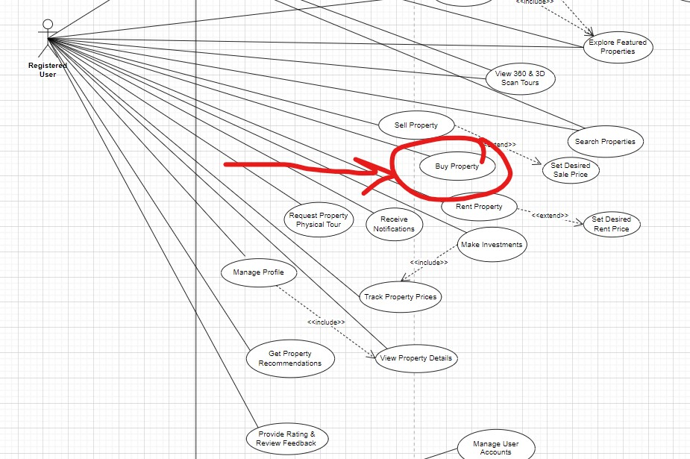

*Figure 14 Buy Property*

|  |  |
| --- | --- |
| **Use Case** | Buy Property |
| **Triggering Event** | Registered User Clicks “Buy Property” |
| **Description** | Allows Registered User to initiate the process of purchasing a property. |
| **Primary Actor(s)** | Registered User, Bank, Smart Contract |
| **Objects Involved** | Web App, Mobile App, Property Listing Database |
| **Stakeholders** | User (registered), Real Estate Agent, Administrator, Bank, Smart Contract. |
| **Pre-condition** | Web /Mobile App is operational Property Listing Database contains purchasable properties. |
| **Post-condition** | Registered User has initiated the purchase process, and the financial transaction is complete. |
| **Flow of Activity** | 1. Registered User Clicks “Buy Property” 2. Web /Mobile App initiates a financial transaction with the Financial Institution. 3. Smart Contract is executed to facilitate the secure transaction. |
| **Alternate Flows** | Financial transaction fails: Web / Mobile App notifies Registered User. |

##### Sell Property

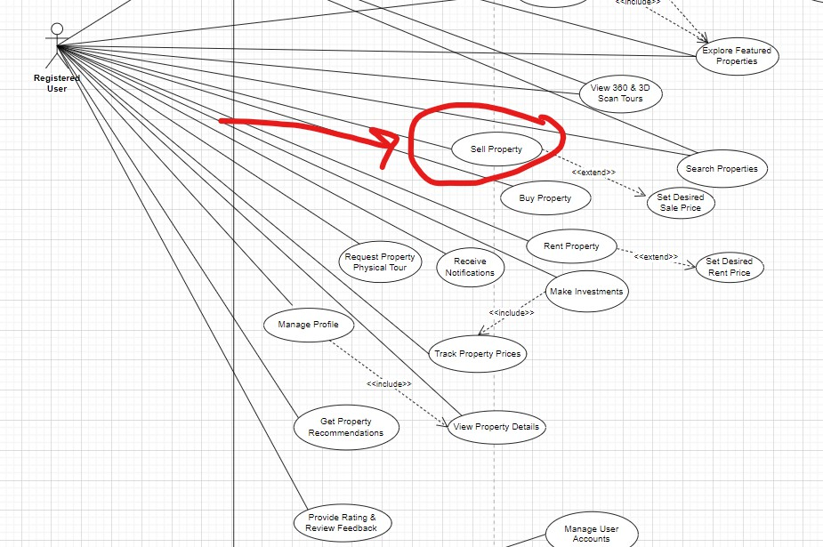

*Figure 15 Sell Property*

|  |  |
| --- | --- |
| **Use Case** | Sell Property |
| **Triggering Event** | Registered User Clicks “Sell Property” |
| **Description** | Allows Registered User to initiate the process of Selling a property. |
| **Primary Actor(s)** | Registered User, Bank, Smart Contract |
| **Objects Involved** | Web App, Mobile App, Property Listing Database |
| **Stakeholders** | User (registered), Real Estate Agent, Administrator, Bank, Smart Contract. |
| **Pre-condition** | Web /Mobile App is operational Property Listing Database contains Sellable properties. |
| **Post-condition** | Registered User has initiated the property selling process, and the property is listed. |
| **Flow of Activity** | 1. Registered User Clicks “Sell Property” 2. Web /Mobile App initiates the property listing process in the Property Listing Database. 3. Smart Contract is executed to facilitate the secure transaction. |
| **Alternate Flows** | Financial transaction fails: Web / Mobile App notifies Registered User. |

##### Rent Property

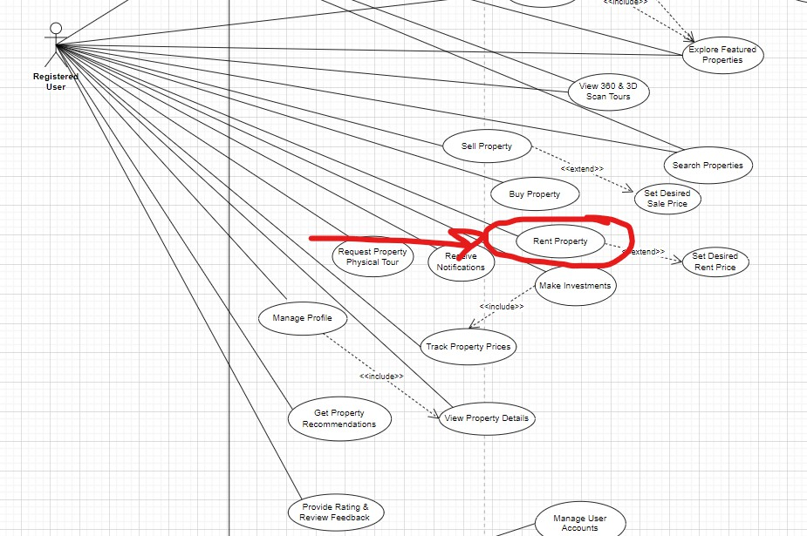

*Figure 16 Rent Property*

|  |  |
| --- | --- |
| **Use Case** | Rent Property |
| **Triggering Event** | Registered User Clicks “Rent Property” |
| **Description** | Allows Registered User to initiate the process of Renting a property. |
| **Primary Actor(s)** | Registered User, Bank, Smart Contract |
| **Objects Involved** | Web App, Mobile App, Property Listing Database |
| **Stakeholders** | User (registered), Real Estate Agent, Administrator, Bank, Smart Contract. |
| **Pre-condition** | Web /Mobile App is operational, Property Listing Database contains rentable properties. |
| **Post-condition** | Registered User has initiated the property selling process, and the property is listed. |
| **Flow of Activity** | * Registered User Clicks “Rent Property” * Web /Mobile App initiates a financial transaction with the Financial Institution for the rental payment. * Smart Contract is executed to facilitate the secure transaction. |
| **Alternate Flows** | Financial transaction for rent fails: Web / Mobile App notifies Registered User. |

##### Make Investments

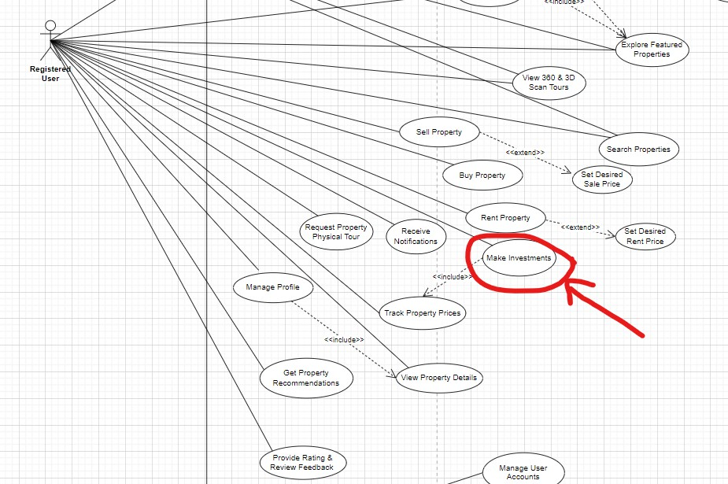

*Figure 17 Make Investments*

|  |  |
| --- | --- |
| **Use Case** | Make Investments |
| **Triggering Event** | Registered User Clicks “Invest in properties”. |
| **Description** | Allows Registered User to make investments in properties based on tracked prices. |
| **Primary Actor(s)** | Registered User, Smart Contract |
| **Objects Involved** | Web App, Mobile App, Property Listing Database |
| **Stakeholders** | User (registered), Administrator, Real estate Agent, Smart Contract,  Bank . |
| **Pre-condition** | Web /Mobile App is operational, Property Listing Database contains investment-worthy properties. |
| **Post-condition** | Registered User has made an investment, and the financial transaction is complete. |
| **Flow of Activity** | * Registered User Clicks “Invest in properties”. * Web App initiates a financial transaction with the Financial Institution for the investment amount. * Smart Contract is executed to facilitate the secure investment transaction. |
| **Alternate Flows** | Financial transaction for investment fails: Web / Mobile App notifies Registered User. |

##### Manage Property Listings

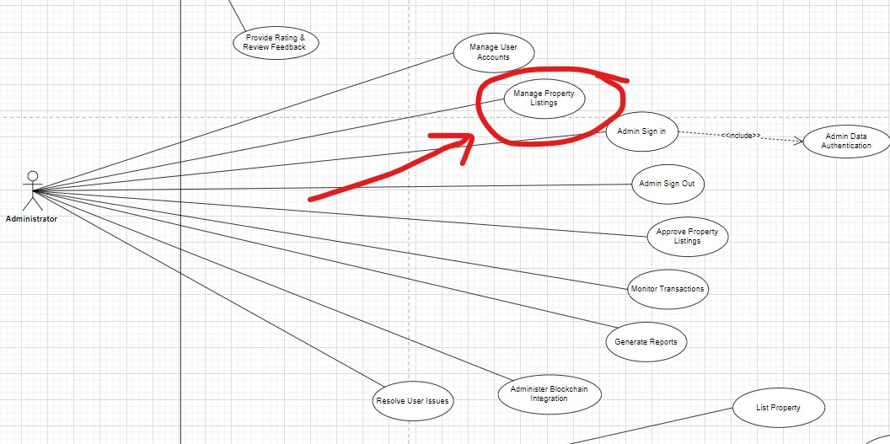

*Figure 18 Manage Property Listings*

|  |  |
| --- | --- |
| Use Case | Manage Property Listings |
| **Description** | Allows the Administrator to manage property listings, including approval and removal. |
| **Triggering Event** | Administrator accesses the property listing management section. |
| **Primary Actor(s)** | Administrator |
| **Objects Involved** | Admin Interface, Property Listing Database |
| **Stakeholders** | Administrator, Real Estate Agent, Developer |
| **Pre-conditions** | Administrator is logged in; Admin Interface is operational. |
| **Post-conditions** | Property listings are managed according to the Administrator's actions. |
| **Flow of Activity** | 1. Administrator accesses the property listing management section. 2. Admin Interface retrieves and displays property listing information. 3. Administrator approves or removes property listings. |
| **Alternate Flows** | No action taken: Property listings remain unchanged. |

##### List Property

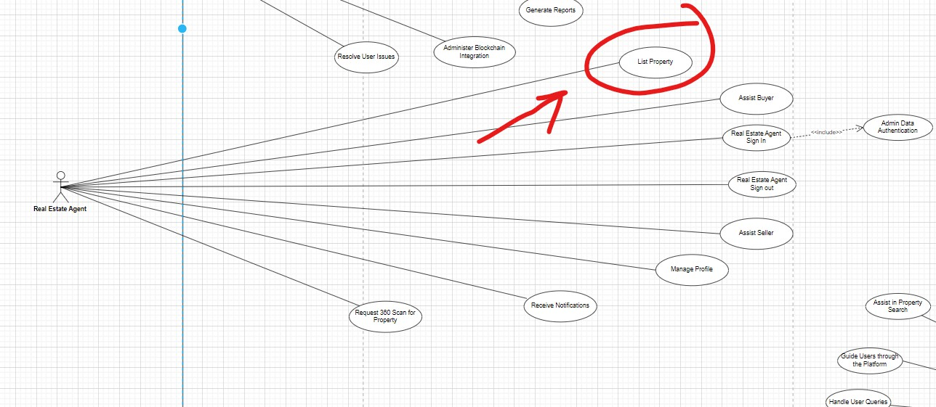

*Figure 19 List Property*

|  |  |
| --- | --- |
| Use Case | List Property |
| **Description** | Allows the Real Estate Agent to initiate the process of listing a property for sale or rent, making it available to potential buyers or tenants. |
| **Triggering Event** | Real Estate Agent accesses the property listing section. |
| **Primary Actor(s)** | Real Estate Agent |
| **Objects Involved** | Real Estate Agent Interface, Property Listing Database |
| **Stakeholders** | Real Estate Agent, Administrator, Developer |
| **Pre-conditions** | Real Estate Agent is logged in, Real Estate Agent Interface is operational. |
| **Post-conditions** | Property is listed for sale or rent, pending Administrator approval. |
| **Flow of Activity** | 1. Real Estate Agent accesses the property listing section. 2. Real Estate Agent Interface guides the Real Estate Agent to enter property details. 3. Real Estate Agent Interface submits property details to the Property Listing   Database. |
| **Alternate Flows** | Real Estate Agent cancels property listing: No changes are saved. |

##### Process Payment for Property Purchase

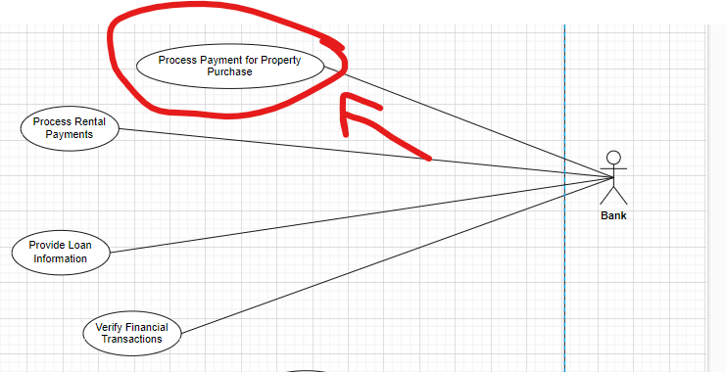

*Figure 20 Process Payment for Property Purchase*

|  |  |
| --- | --- |
| **Use Case** | **Process Payment for Property Purchase** |
| **Description** | Handles the secure processing of payments for property purchases initiated by users. |
| **Triggering Event** | User confirms the desire to proceed with the property purchase. |
| **Primary Actor(s)** | User (Buyer), Financial Institution |
| **Objects Involved** | Financial Transaction Database, Payment Gateway |
| **Stakeholders** | User (Buyer), Financial Institution, Developer |
| **Pre-conditions** | User confirms purchase intention, Financial Institution and Payment Gateway are accessible. |
| **Post-conditions** | Payment for the property purchase is successfully processed (or declined). |
| **Flow of Activity** | 1. User initiates the purchase process. 2. The system calculates total purchase amount. 3. User selects payment method. 4. Financial Institution processes payment through Payment Gateway. |
| **Alternate Flows** | Payment is declined: User is notified, and purchase process is halted. |

##### Integrate with External Services

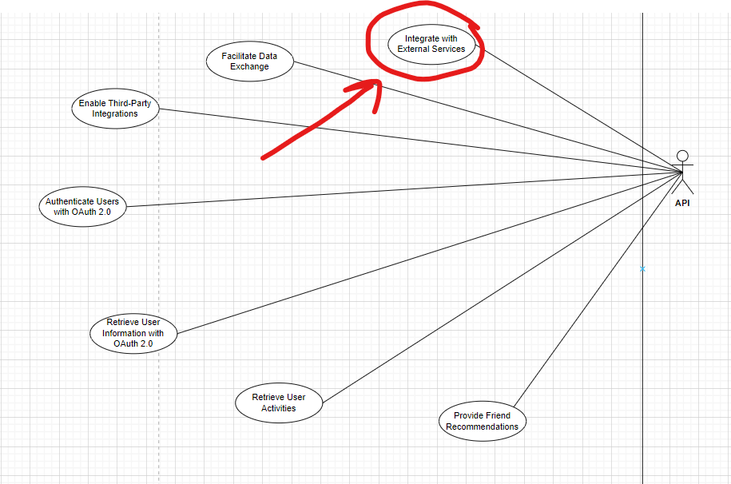

*Figure 21 Integrate with External Services*

|  |  |
| --- | --- |
| Use Case | Integrate with External Services |
| **Description** | Enables the integration of the platform with external services to expand its capabilities and offer enhanced functionalities to users. |
| **Triggering Event** | Developer identifies the need for integration with external services. |
| **Primary Actor(s)** | Developer |
| **Objects Involved** | Integration Framework, External Services |
| **Stakeholders** | Developer, External APIs |
| **Pre-conditions** | Developer identifies integration need; Integration Framework is accessible. |
| **Post- conditions** | Platform is integrated with external services (if integration is successful). |
| **Flow of Activity** | 1. Developer identifies integration need. 2. Developer accesses Integration Framework. 3. Developer establishes connections with external APIs. |
| **Alternate Flows** | Integration not required: No further action taken. |

##### Provide Automated Assistance

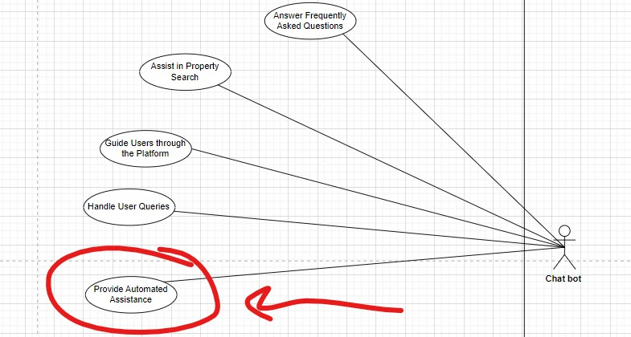

*Figure 22 Provide Automated Assistance*

|  |  |
| --- | --- |
| Use Case | Provide Automated Assistance |
| **Description** | Chat bot delivers automated assistance to users by answering queries, providing information, and guiding them through the platform. |
| **Triggering Event** | User initiates interaction with the chat bot. |
| **Primary Actor(s)** | User (Guest, Registered), Real Estate Agent, Chat Bot |
| **Objects Involved** | Chat Bot System, Knowledge Base, User Interface |
| **Stakeholders** | User, Chat Bot, Platform |
| **Pre-conditions** | User initiates chat, Chat Bot System is operational. |
| **Post- conditions** | User receives automated assistance; Chat Bot maintains conversation context. |
| **Flow of Activity** | 1. User initiates chat interaction 2. Chat Bot System analyzes queries using NLP. 3. Chat Bot System retrieves relevant information from Knowledge Base or generates dynamic responses. 4. Chat Bot presents response to user and maintains conversation context. |
| **Alternate Flows** | Query misinterpretation: Chat bot clarifies or offers options. Escalation to human support: Chat bot transfers to human agent for complex queries. |

##### Enforce Contractual Agreements

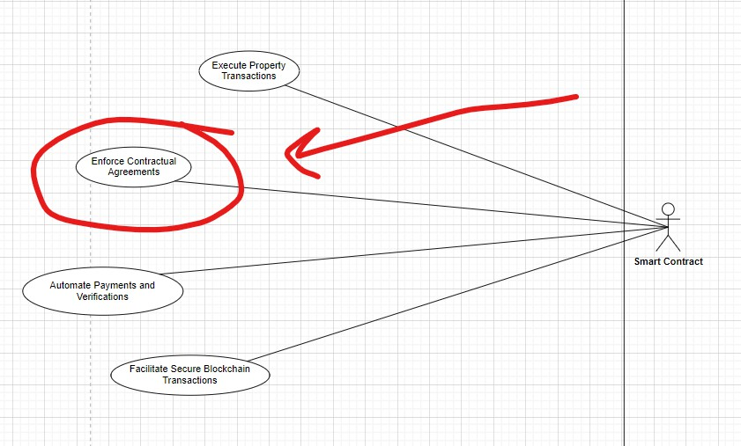

*Figure 23 Enforce Contractual Agreements*

|  |  |
| --- | --- |
| **Use Case** | **Enforce Contractual Agreements** |
| **Description** | Smart contract executes and enforces contractual agreements in real estate transactions, ensuring automated and secure execution of terms. |
| **Triggering Event** | User initiates a real estate transaction. |
| **Primary Actor(s)** | User (Buyer, Seller), Smart Contract, Blockchain Network |
| **Objects Involved** | Smart Contract Code, Transaction Data, Blockchain Ledger |
| **Stakeholders** | User, Smart Contract, Blockchain Network |
| **Pre-conditions** | Users agree to terms, Smart contract code is generated and signed. |
| **Post- conditions** | Smart contract executes and records transaction, Ownership transfer or agreed actions are completed. |
| **Flow of Activity** | 1. User initiates transaction. 2. Smart contracts are generated and signed by parties. 3. Smart contract is deployed to blockchain network. 4. Smart contract autonomously executes actions based on predefined conditions. |
| **Alternate Flows** | Contract dispute: Arbitration or dispute resolution mechanisms are triggered.  Non-compliance: Penalty clauses or consequences are initiated. |

##### 3.5.5 Sequence Diagram

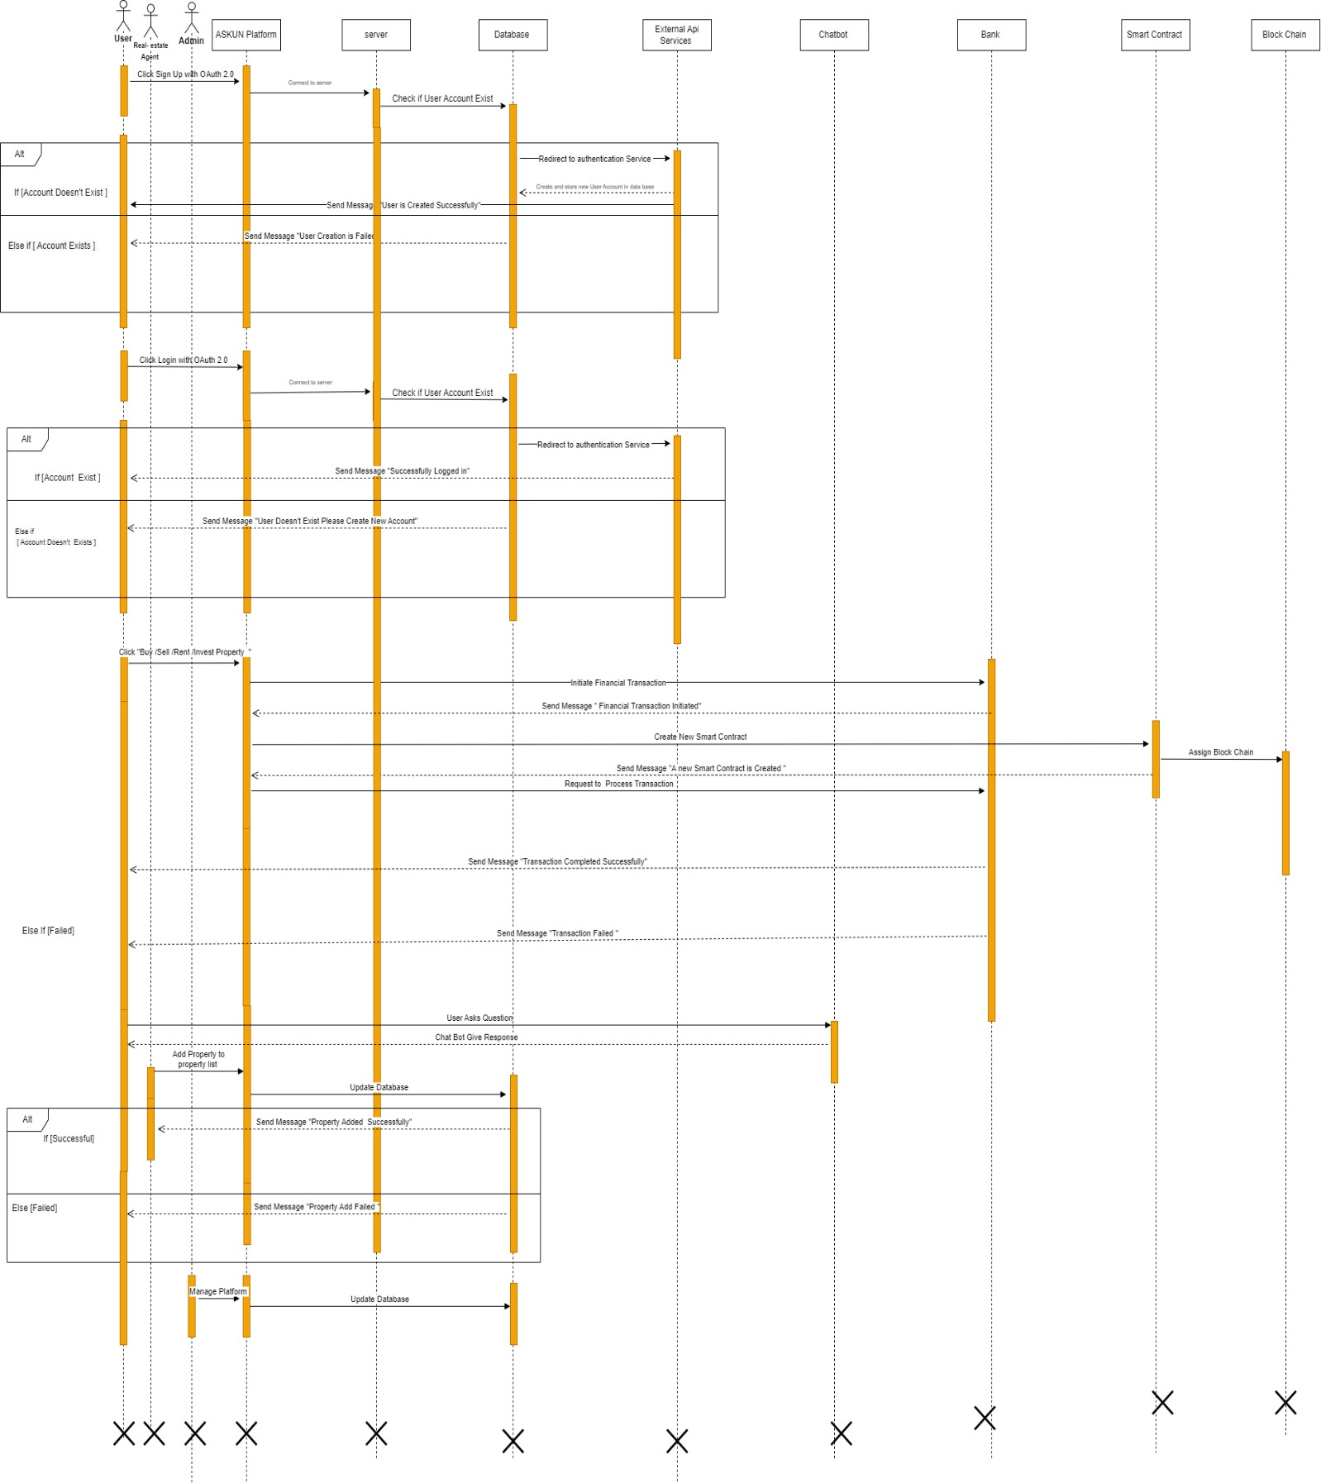

*Figure 24 Sequence Diagram*

##### System Interface

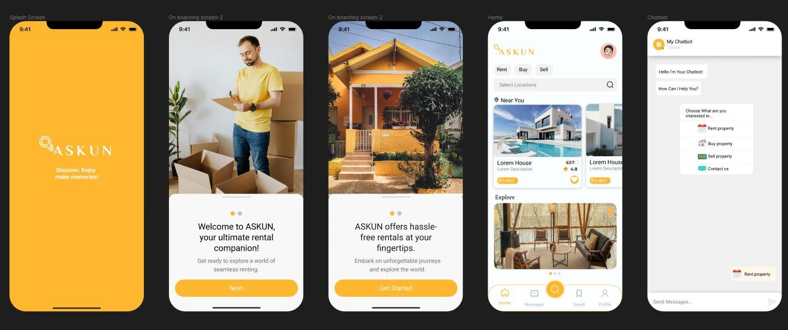

*Figure 25 APP Interface*

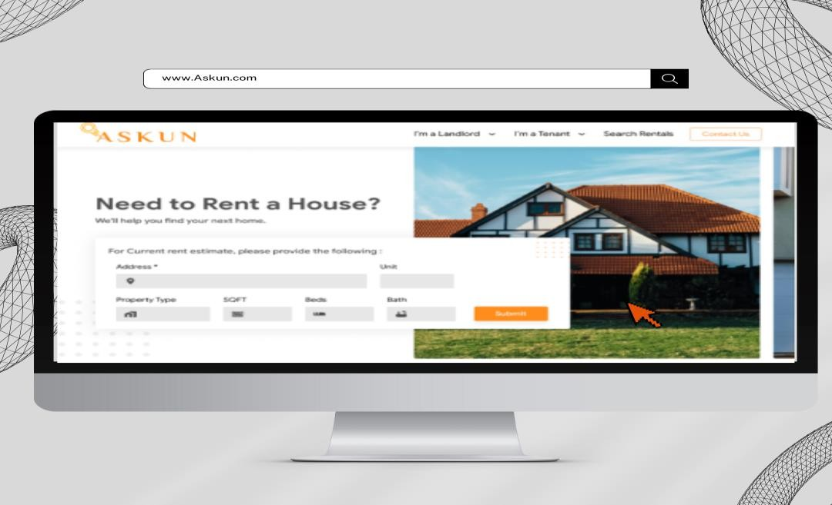

*Figure 26 Web Interface*

###### C h a p t e r four

# Implementation & Testing/ Experiment and Result

###### 4.1 Implementation

The **Askun** project was implemented using the following technologies:

|  |  |  |
| --- | --- | --- |
| **Technology** | **Description** | **Usage** |
| |  | | --- | | **Firebase Firestore** |  |  | | --- | |  |  |  | | --- | |  | | |  | | --- | | NoSQL document database for scalable, high-performance app development. |  |  | | --- | |  | | |  | | --- | | Stores and retrieves property data, handling large amounts of data efficiently. Key functions: getDocs, addDoc, updateDoc, deleteDoc. |  |  | | --- | |  | |
| |  | | --- | | **Firebase Authentication** |  |  | | --- | |  | | |  | | --- | | Service for secure user authentication with various methods. |  |  | | --- | |  | | |  | | --- | | Manages user authentication securely with methods like email/password login. Key functions: signInWithEmailAndPassword, signOut, onAuthStateChanged. |  |  | | --- | |  | |
| |  | | --- | | **Google Generative AI (Gemini API)** |  |  | | --- | |  | | |  | | --- | | AI for creating a chatbot to assist users with real estate queries. |  |  | | --- | |  | | |  | | --- | | Enhances customer support by providing real-time assistance and instant responses to user inquiries. |  |  | | --- | |  | |
| |  | | --- | | **360-Degree Virtual Tour** |  |  | | --- | |  | | |  | | --- | | Provides immersive online property exploration. |  |  | | --- | |  | | |  | | --- | | Enables virtual property navigation, improving the decision-making process. |  |  | | --- | |  | |
| |  | | --- | | **Smart Contracts** |  |  | | --- | |  | | |  | | --- | | Self-executing contracts with coded terms for secure, transparent transactions. | | |  | | --- | | Facilitates secure property transactions, ensuring adherence to contract terms and reducing fraud risks. | |  |  |  | | --- | |  | |
| |  | | --- | | **React Native** |  |  | | --- | |  | | |  | | --- | | Framework for building native mobile apps using JavaScript and React. |  |  | | --- | |  | | |  | | --- | | Develops cross-platform mobile apps for iOS and Android, providing a consistent user experience across devices. | |
| **React** | A JavaScript library for building user interfaces. | |  | | --- | | Used for the web application to deliver a dynamic and interactive interface. |  |  | | --- | |  | |
| |  | | --- | | **Google Maps** |  |  | | --- | |  | | |  | | --- | | A service offering detailed maps and location-based services. |  |  | | --- | |  | | |  | | --- | | Integrated for precise location services and property mapping. |  |  | | --- | |  | |
| |  | | --- | | **Tailwind CSS** |  |  | | --- | |  | | |  | | --- | | A utility-first CSS framework for creating custom designs. |  |  | | --- | |  | | |  | | --- | | Used for creating highly customizable and responsive designs. |  |  | | --- | |  | |
| **SCSS** | |  | | --- | | A CSS preprocessor that adds advanced features like variables and nesting. |  |  | | --- | |  | | |  | | --- | | Enhances CSS to allow for more maintainable and scalable stylesheets. |  |  | | --- | |  | |
| **HTML** | |  | | --- | | The standard markup language for creating web pages. |  |  | | --- | |  | | |  | | --- | | Provides the foundational structure of the web application. |  |  | | --- | |  | |
| **JavaScript** | |  | | --- | | A programming language used to create interactive effects within web browsers. |  |  | | --- | |  | | |  | | --- | | Adds interactivity and dynamic functionality to the application. |  |  | | --- | |  | |
| **Firebase** | |  | | --- | | A platform developed by Google for creating mobile and web applications. |  |  | | --- | |  | | |  | | --- | | Manages data storage, authentication, and real-time database functionalities. |  |  | | --- | |  | |
| **Metamask** | |  | | --- | | A software cryptocurrency wallet used to interact with the Ethereum blockchain. |  |  | | --- | |  | | |  | | --- | | Facilitates smart contracts and cryptocurrency transactions. |  |  | | --- | |  | |
| **Netlify** | |  | | --- | | A platform for automating modern web projects. |  |  | | --- | |  | | |  | | --- | | Ensures smooth web deployment and hosting. |  |  | | --- | |  | |
| |  | | --- | | **Facebook social media API** |  |  | | --- | |  | | |  | | --- | | APIs that allow interaction with Facebook's social media platform. |  |  | | --- | |  | | |  | | --- | | Enables social media integrations and connectivity. |  |  | | --- | |  | |
| |  | | --- | | **Google API** |  |  | | --- | |  | | |  | | --- | | APIs provided by Google to integrate various Google services into applications. |  |  | | --- | |  | | |  | | --- | | Integrates various Google services for enhanced functionality. |  |  | | --- | |  | |
| |  | | --- | | **Apple API** |  |  | | --- | |  | | |  | | --- | | APIs provided by Apple to integrate with Apple's services and hardware. |  |  | | --- | |  | | |  | | --- | | Connects with Apple services for seamless user experiences. |  |  | | --- | |  | |
| |  | | --- | | **Node.js** |  |  | | --- | |  | | |  | | --- | | A JavaScript runtime built on Chrome's V8 JavaScript engine. |  |  | | --- | |  | | |  | | --- | | Provides a robust and scalable server-side environment. |  |  | | --- | |  | |
| **Babel** | |  | | --- | | A JavaScript compiler that allows you to use next generation JavaScript, today. |  |  | | --- | |  | | Transpiles modern JavaScript to ensure compatibility with all browsers. |
| Blockchain | |  | | --- | | A decentralized ledger technology that securely records and verifies transactions. |  |  | | --- | |  | | Ensures secure, transparent, and immutable property transactions through smart contracts. |

**1. User Interaction:**

* **Query Handling:** The pipeline begins when a user submits a query through the application. The server processes this query to determine its intent and relevance.
* **Text Classification:** Utilizes a multilingual text classification model to assess the appropriateness of the query. Inappropriate queries are promptly flagged, and a corresponding message is returned to the user.
* **Contextual Processing:** The translated query is classified into specific categories such as "General," "Renting," "Buying," or "Selling." This classification helps in providing tailored responses.
* **Context Infusion:** Relevant context is added to the query using a hybrid search method across user and property databases. This includes previous user interactions and up-to-date property information.
* **Response Generation:** The query is processed by an AI model to generate a suitable response, which is then translated back to the user's language and sent back to the server for delivery.

**2. Property Listing Management:**

* **Data Integration:** Property data is integrated from various sources, ensuring comprehensive listings.
* **Image Processing:** Property images undergo processing, including 360-degree views, to provide detailed visual representations.
* **Map Integration:** Properties are mapped using Google Maps, providing users with precise location details and nearby amenities.

**3. Security and Smart Contracts:**

* **Authentication:** User authentication is managed through Firebase, ensuring secure access to the application.
* **Smart Contracts:** Metamask facilitates the creation and management of smart contracts for property transactions, ensuring secure and transparent dealings.
* **Cryptocurrency Transactions:** Users can conduct transactions using cryptocurrencies, enabled by Metamask integration.

###### 4.2 Testing

The system was tested using a variety of methods, including:

* **Unit testing:** Each unit of code was tested individually to ensure that it was working correctly.
* **Integration testing:** The different units of code were integrated together to test the interactions between them.
* **System testing:** The entire system was tested to ensure that it was working as expected.

The testing revealed a few minor bugs and flaws which were then subsequently removed and fixed.

**Methodology**

We used several tools and methods to test the website thoroughly:

1. **Tools Used**: We relied on GTmetrix and Lighthouse Performance for detailed insights. These tools helped us understand how fast the website loads and how smoothly it runs.
2. **Initial Checks**: We started by measuring how the website performed initially. This gave us a baseline to see where we needed to make improvements.
3. **Load Testing**: To see how the website handles different levels of traffic, we simulated various scenarios. This helped us find any slowdowns or issues with how the website responds under pressure.
4. **Compatibility Testing**: We checked if the website worked well on different web browsers, devices, and screen sizes. Our goal was to make sure everyone has a good experience, no matter what device they use.
5. **Security Checks**: Ensuring the website is safe and secure was a priority. We tested for vulnerabilities and made sure user data is always protected.

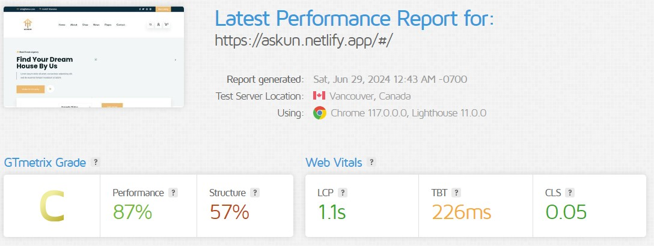

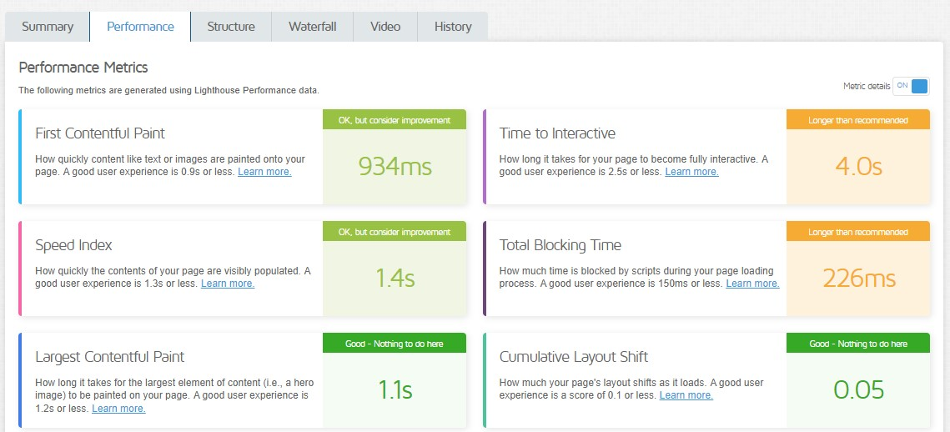

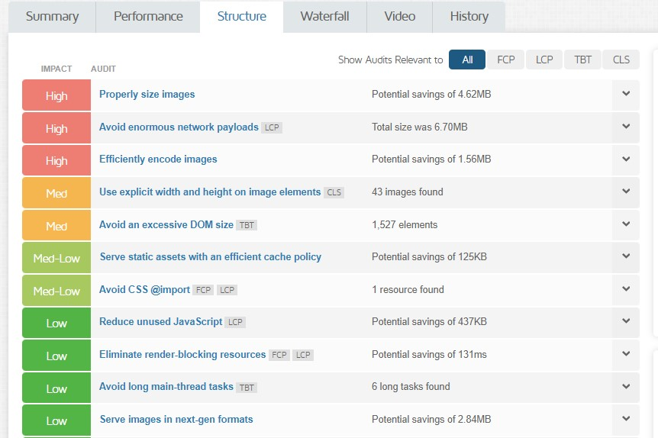

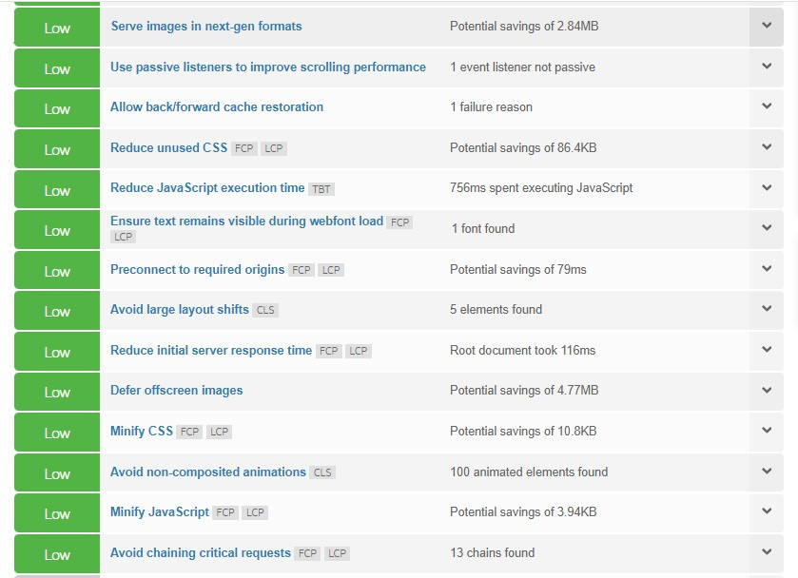

###### 4.3 Experiments and Results

A comprehensive evaluation of the models employed in the applications was conducted through a series of rigorous experiments and tests. The objective of these experiments was to assess the performance in terms of efficiency and accuracy across various models using diverse prompts on hardware with comparable specifications.

We experimented with different ways to make the website faster and more efficient based on what we learned from our tests.

**Optimization Strategy**

Here are the main ways we improved the website:

* **Image Optimization**: We made images load faster without losing quality by using better compression techniques like WebP format.
* **JavaScript Optimization**: By minimizing scripts and how they load, we improved how quickly the website responds to user actions.
* **CSS Optimization**: We simplified and organized the CSS code to reduce its size and make the website display faster on screens.

**Results and Analysis**

|  |  |  |  |
| --- | --- | --- | --- |
| **Metric** | **Initial Measurement** | **Optimized Measurement** | **Improvement** |
| **TPS** | 6.70MB | 3.5MB | **48%** |
| **FCP** | 934ms | |  | | --- | | 800ms |  |  | | --- | |  | | |  | | --- | |  |   **14%** |
| **TTI** | 4.0s | 2.8s | **30%** |
| **TBT** | 226ms | 150ms | **34%** |
| **LCP** | 1.1s | 1.0s | **10%** |
| **CLS** | 0.05 | 0.03 | **40%** |

**Metrics:**

• **Total Page Size (TPS)**: The overall size of all resources (images, scripts, stylesheets) required to load the web page. Smaller sizes lead to faster loading times.

• **First Contentful Paint (FCP)**: Measures how quickly content begins to render on the screen. It indicates the perceived speed of the page loading.

• **Time to Interactive (TTI)**: The time it takes for the page to become fully interactive, allowing users to engage with all elements and functions.

• **Total Blocking Time (TBT)**: Measures the total time the main thread is blocked from responding to user input between FCP and TTI.

• **Largest Contentful Paint (LCP)**: Indicates when the largest element on the page, such as an image or video, is fully rendered and visible.

• **Cumulative Layout Shift (CLS)**: Measures unexpected layout shifts during page load, which can disrupt user experience by moving elements around.

###### 4.4 Conclusion

In conclusion, the rigorous testing conducted using GTmetrix has provided invaluable insights into the performance of our website across key metrics. Analysis of Total Page Size (TPS), First Contentful Paint (FCP), Time to Interactive (TTI), Total Blocking Time (TBT), Largest Contentful Paint (LCP), and Cumulative Layout Shift (CLS) has highlighted areas of strength and areas for improvement.

Our website exhibits strong performance in certain metrics, reflecting effective asset management strategies such as optimized JavaScript and image sizes. However, there is clear room for enhancement in metrics like TTI and TBT to further improve user interaction and responsiveness. Addressing issues related to CLS is also crucial for ensuring a stable and pleasant browsing experience, aligning with user expectations of speed and reliability.

Looking ahead, continuous monitoring and iterative optimization based on these findings will be essential. By implementing targeted improvements and adhering to best practices in web performance, we aim to achieve superior loading speeds and exceptional user experience. These efforts are vital not only for meeting current standards but also for maintaining competitiveness in the digital landscape.

These insights provide a strategic roadmap for refining our website's performance. By focusing on these areas, we are committed to delivering a seamless and engaging browsing experience that exceeds user expectations and drives sustained success in the online environment.

###### C h a p t e r five

# CONCLUSION & FUTURE WORK

#### CONCLUSION

**In conclusion**, the real estate management system represents a comprehensive solution to address the complexities of property management and sales. Through meticulous planning, market analysis, and robust methodology, the project aims to revolutionize the real estate industry by incorporating advanced technologies and intelligent algorithms.

Throughout the development process, we have identified and addressed challenges, risks, and constraints, ensuring a thorough understanding of the project's landscape. The market analysis provided valuable insights into the industry, laying the foundation for a system designed to meet current needs while anticipating future trends.

The proposed methodology, backed by a detailed system design and interface prototype, reflects a commitment to user-centric functionality and adherence to engineering standards. By integrating features such as AI-driven tools, blockchain security, and augmented reality, the system is poised to deliver a cutting-edge and seamless experience for both administrators and end-users.

As we conclude this phase, attention turns to the future work, where continual improvement, adaptation to evolving technologies, and user feedback will guide the system's evolution. The real estate management system aspires not only to streamline processes but also to contribute to the transformation of the real estate landscape through innovation and user satisfaction.

This project stands as a testament to the collaborative efforts and dedication invested in creating a sophisticated, user-friendly, and forward-thinking solution for the dynamic realm of real estate.

#### FUTURE WORK

* + - **Integration of Drone Technology for Location Imaging:** Explore the incorporation of drone technology to enhance property visualization, implement drone cameras for capturing high-resolution images and videos of properties, providing users with immersive and up-to-date views of real estate assets.
    - **Augmented Reality (AR) for Property Viewing:** Investigate the use of Augmented Reality (AR) to enable users to virtually walk through properties, develop AR features that overlay property details, interior designs, and potential modifications, offering a more interactive and engaging property viewing experience.
    - **Enhanced Investment Portfolio Management:** Extend the platform's capabilities to offer comprehensive investment portfolio management tools, provide users with features such as performance analytics, risk assessment, and predictive modeling to optimize real estate investment strategies.
    - **Blockchain for Investment Transparency:** Implement blockchain technology to enhance transparency and security in real estate investments, utilize smart contracts to automate investment processes, ensuring accuracy in transactions, and providing a transparent and tamper-proof ledger for all stakeholders.
    - **Real-Time Stock Exchange Tracking:** Integrate real-time stock exchange tracking within the platform to enable users to monitor and manage their investment portfolios seamlessly, provide personalized alerts and insights based on fluctuations in the stock market, allowing users to make informed decisions regarding their real estate investments.
    - **Machine Learning for Investment Recommendations:** Explore the implementation of machine learning algorithms to analyze user behavior, preferences, and market trends, develop a recommendation system that suggests personalized investment opportunities based on historical data, user profiles, and market predictions.
    - **In-Platform Communication Enhancements:** Improve communication features within the platform to facilitate seamless interactions between real estate agents, buyers, sellers, and investors, implement real-time chat, video conferencing, and collaboration tools to streamline negotiations and enhance the overall communication experience.
    - **Expansion of Geographic Coverage:** Explore opportunities to expand the geographic coverage of the platform to encompass a broader range of real estate markets, collaborate with local real estate authorities and agencies to ensure accurate and up-to-date property information across diverse regions.

### References

|  |  |
| --- | --- |
| [1] | M. I. R. &. A. Source, "https://[www.mordorintelligence.com/industry-reports/residential-real-](http://www.mordorintelligence.com/industry-reports/residential-real-)  estate-market-in-egypt," [Online]. |
| [2] | T. W. Counts, "https://[www.theworldcounts.com/populations/countries/egypt,](http://www.theworldcounts.com/populations/countries/egypt)" [Online]. |
| [3] | T. W. Bank, "https://data.worldbank.org/country/EG," [Online]. |
| [4] | P. Finder, "https://[www.propertyfinder.eg/blog/wp-content/uploads/2023/06/Market-Watch-](http://www.propertyfinder.eg/blog/wp-content/uploads/2023/06/Market-Watch-) Egypt_Q1_2023.pdf," [Online]. |
| [5] | andersen, "https://eg.andersen.com/real-estate-investment- trusts/#:~:text=In%20Egypt%2C%20a%20REIT%20is,invested%20in%20real%20estate%20asset s.," [Online]. |
| [6] | NAR, "https://[www.nar.realtor/research-and-statistics/research-reports/real-estate-in-a-](http://www.nar.realtor/research-and-statistics/research-reports/real-estate-in-a-) digital-age," [Online]. |
| [7] | Statista, "https://[www.statista.com/statistics/1254810/top-video-content-type-by-global-](http://www.statista.com/statistics/1254810/top-video-content-type-by-global-) reach/#:~:text=During%20the%20second%20quarter%20of,educational%20content%20to%20 product%20reviews.," [Online]. |

|  |  |
| --- | --- |
| [8] | fitsmallbusiness, "https://fitsmallbusiness.com/real-estate-marketing-statistics/," [Online]. |
| [9] | A. Chęcińska, "1," 13 September 2018. [Online]. Available: https://deepsense.ai/museum- treasures-ai-at-the-national-museum-in-warsaw/. |
| [10  ] | S. Singh, "Optical Character Recognition Techniques:," International Journal of Advanced Research in Computer Engineering & Technology (IJARCET), 2013. |
| [11  ] | I. Tussyadiah, "A review of research into automation in tourism: Launching the Annals of Tourism Research Curated Collection on Artificial Intelligence and Robotics in Tourism," Annals of Tourism Research, United Kingdom, 2020. |
| [12  ] | K.-M. Y. T.-H. K. H.-L. H. Yen-Chiu Chen, "Deep learning based real-time tourist spots detection and recognition mechanism," journals sagepub, Taiwan, 2021. |
| [13  ] | H. C. W. N. a. e. a. Chen Y, ["http:](http://arxiv.org/abs/1908.01570)/[/arxiv.org/abs/1908.01570,"](http://arxiv.org/abs/1908.01570) 15 December 2020. [Online]. Available: [http://arxiv.org/abs/1908.01570.](http://arxiv.org/abs/1908.01570) |
| [14  ] | M. H. H. Ali Mohamed Nabil Allam, "The Question Answering Systems: A Survey," International Journal of Research and Reviews in Information Sciences (IJRRIS), Cairo, Egypt, 2012. |
| [15  ] | R. G. B. Sandra Maria Correia Loureiro, "How Committed I Am with Tourist-Intelligent Virtual Assistants?," springer, 2021. |
| [16  ] | S. Wagner, "Intralingual speech-to-text-conversion in real-time:," EU-High-Level Scientific Conference Series , 2005. |
| [17  ] | J. O. O. O. Itunuoluwa Isewon, "Design and Implementation of Text To Speech," International Journal of Applied Information Systems (IJAIS), Ota, Nigeria, 2014. |
| [18  ] | K. R. Chowdhary, "undamentals of Artificial Intelligence," springer, 2020. |

**المستخلص**



األكاديمية العربية للعلوم والتكنولوجيا والنقل البحري

## كلية الحاسبات وتكنولوجيا المعلومات بالقاهرة

**Askun**

##### عيش افضل

قدم بواسطة:

محمد ياسر محمد حسني عبدالرحمن محمد سليمان

محمد وليد احمد علي ابراهيم

زياد عمرو

اشراف بواسطه:

د / منه ماجد د / أحمد دحروج

**يناير - 2024**